The Science of Dangerous Decibels
Background Information for the Educator

The Physics of Sound

Sound occurs when energy travels as waves of pressure through a substance such as air, water, or even solid materials. Almost anything that vibrates can produce sound. When something vibrates it pushes the particles around it, and those particles in turn push the air particles around them, carrying the pulse of the vibration in all directions from the source. The particles themselves don’t move very far, but the transfer of energy can be very fast – about 760 miles/hour in air, depending on the temperature and humidity. Sound travels about 5 times faster in water and about 14 times faster in steel than in air because the molecules are closer together and the motion can be transferred more rapidly.
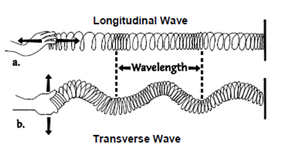
Sound waves are called “longitudinal” pressure waves, which are different from the “transverse” waves we’re familiar with in water because the molecules move back & forth rather than up and down (see diagram below).
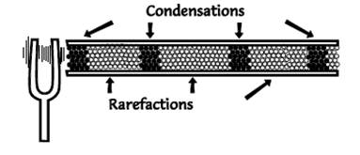
Sound has three characteristics basic to how we experience it: loudness, pitch, and timbre. The loudness of a sound results from the difference in pressure between the compressed areas (condensation) and the rarefied areas (rarefaction) – a greater difference being louder. (See diagram below showing a graphical representation of the sound produced by a tuning fork.)
Pitch results from the rate or “frequency” of the vibrations, which we experience as higher and lower tones like the “do – re – mi” of a musical scale. The frequency of vibrations is not the same as the speed of sound. Different frequencies all travel at the same speed in the same medium – imagine listening to music if they didn’t!
The timbre is what makes a sound distinct and recognizable as a particular instrument, voice, vowel sound, or just noise. Almost all vibrating objects create several vibrations of various frequencies and intensities in addition to the main or “fundamental” frequency. These are called “overtones” and if they are simple whole number multiples or “harmonics” of the fundamental frequency (2x, 3x, 4x...) we hear the overall sound as a pleasing or musical tone. If they are a more random combination of frequencies we usually just call it noise.
Different sources may create the same fundamental note with all the same harmonics, but individual harmonics are louder or softer depending on the source. That’s what makes violins, saxophones, and voices all sound unique.
This is also how we create vowel sounds: by altering the shape of our mouth, we change which harmonics resonate loudly and which are suppressed. So, if you lose the ability to hear the higher tones it can become difficult to hear the difference between an “a” “e” “i” “o” and “u”. The result is not just an inability to hear high-pitched sounds, but to distinguish one type of sound from another!
See the following website for more information and illustrations about the physics of music as described by the School of Physics at the University of New South Wales, Australia - http://www.phys.unsw.edu.au/jw/strings.html .

Fun Facts about Sound:
- Sound travels at 760 miles/hr.
Have older students calculate how long it takes for sound to travel one mile. (sound travels 1 mile in a little less than 5 seconds)
For example, during a storm you can calculate the distance to a lightning strike by counting the seconds between a lightning strike and the resulting thunder and then dividing it by 5 to get the approximate distance in miles!
- Frequency and wavelength are inversely related (freq. = speed of sound/ wavelength), so given the range of voices from bass to soprano we can figure that the sound waves coming from our mouth are between 1 and 12 feet long!
- The actual difference in the density of the compressed and rarefied air in a sound wave, from a piano string for example, is only about 1/100th of a 1%!

Add more fun facts that you or your students find below:

More Fun Facts about Sound

