SCI 265 Exploring Polymers
Name: ________________________Group: _____
- What are all the different types of polymers that you have heard of?

Investigating polymers
Balloon skewers
Blow up a balloon and tie it off. Now use a wooden skewer and carefully poke it through the balloon from one side to the other.
Try two different locations:
- The side of the balloon. This is where the rubber is stretched the most. What happens?

- The darker part right next to where you tied it off, straight across to the dark spot on the end of the balloon. These two spots are thicker. What happens?

Fish in a bag
A young man goes to the pet store and brings home a gold fish in a zip top baggy. As he’s walking home, the fish gets an attitude and starts calling the young man names. The young man is irritated and pokes the gold fish with a very sharp pencil!
- Take a zip top baggy and fill it with water and seal it. Now take a very sharp pencil and carefully poke it through the side of the baggy. What happens?

Leprechaun eggs / jelly marbles
- The tank in the back has what are sometimes referred to as leprechaun eggs hidden in it. Feel free to investigate! Describe what you found.

Make your own polymers
Polymer #1
Material Needed

- 250-mL beaker
- 50-mL beaker
- 10-mL graduated cylinder
- Glass stirring rod
- Petri dish
- 25 mL Elmer’s Glue-All
- 20 mL water
- 5 mL borax solution

Measure 25 mL of Elmer’s glue in the 50-mL beaker and pour into 250 mL beaker.
Measure 20 mL of tap water with the graduated cylinder. Add to the glue and stir well.
Measure 5 mL of borax solution with the graduated cylinder and stir into mixture.
The solid material can be removed and kneaded (it will be sticky at first). Knead the material and set it aside in a petri dish.
- Describe the substance that you made.

Polymer #2
Material Needed

- 50-mL beaker
- 10-mL graduated cylinder
- Glass stirring rod
- Petri dish
- 25 mL Elmer’s Glue-All
- 20 mL polyvinyl alcohol
- 2 mL borax solution

Measure 20 mL of polyvinyl alcohol into a 50 mL beaker.
Measure 2 mL of borax solution using the graduated cylinder. Add the borax solution to the polyvinyl alcohol and stir quickly.
Remove the solid material and place in a petri dish.
- Describe the substance that you made.

Changing the composition of materials
Now make some of polymer #1 and polymer #2 where you change the amount of one ingredient in the mix. Keep careful record of what you changed for each one.
- Describe how you changed the recipe for Polymer #1.

- How does polymer #1 compare to your new version of #1?

- Describe how you changed the recipe for polymer #2?

- How does polymer #2 compare to your new version of #2?

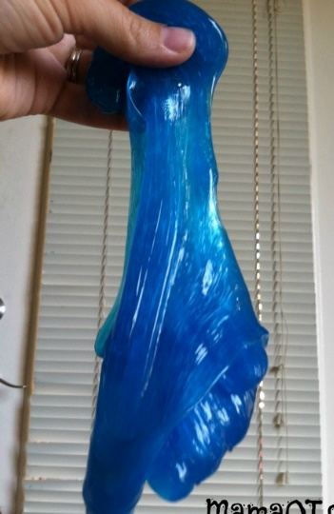
- One neat characteristic of this type of polymer is how it stretches. Test all four of your newly made polymers and compare their stretchiness. Document below.
Hint: This works best if you hold it up and let gravity do the stretching.

More polymers
The petri dish, the materials bin and your chair seat are also polymers!
- Describe these three items.

- How are they different from the other polymers you’ve investigated today?

- How are they similar to the other polymers you’ve investigated today?

- In what ways are they different from each other?

- In what ways are they similar to each other?

Characteristics of Polymers
- In the top row of the table below, list four characteristics that you can use to describe each type of polymer. For example bounciness, stretchiness, etc….
- Now fill in the table for each polymer you investigated today.
Polymer
Balloon
Zip top baggy
Jelly marbles
Polymer #1
Polymer #2
New #1
New #2
Petri dish
Materials bin
Chair seat

- Look at your table and see if every polymer has a unique set of characteristics. If there are two (or more) that have the exact same description in the table, then you know you need another characteristic to differentiate your polymers. Use column 5 to do this.
Check with your instructor

