SCI 265 – Investigating Density, Volume, Mass and Weight
Name: ____________________ Group: _____
Density, Volume and Mass

Play around with the PhET simulation Density.
Choose: “Custom” and “My Block”

If you change the mass of the block, how does the block change?

- If you change the volume of the block, how does the block change?

- How does the density of the block change when you adjust the volume?

- How does the density of the block change when you adjust the mass?

Prediction: If you have several blocks of the same mass, will they all float or all sink the same in water?

Try out the button “Same Mass” Explain what is different and what is the same about each of these blocks.
A. Compare features you can observe out of the water.

B. Compare the behavior in water.

Prediction: If you have several blocks of the same volume, will they all float or all sink the same in water?

- Try out the button “Same Volume” Explain what is different and what is the same about each of these blocks.
A. Compare features you can observe out of the water.

B. Compare the behavior in water.

Prediction: If you have several blocks of the same density, will they all float or all sink the same in water?

- Try out the button “Same Density” Explain what is different and what is the same about each of these blocks.
A. Compare features you can observe out of the water.

B. Compare the behavior in water.

Low Density Water High Density

0 0.5 1 1.5 2 2.5 3 3.5

Density (kg/L)

Write these labels under the density scale above:
Sinks quickly
Barely sinks
Barely floats
Floats well
Check your answers with your instructor

Rank the relative density of the five mystery blocks A – E compared to each other and to water. Write a clear description of how you determined the order.

- The grey brick on the supplies cart is solid lead. This gives you an idea of how something very dense feels. It has a density of 11.4 g/ml. Believe it or not, gold is nearly twice as dense as this lead brick at 19.3 g/ml! What did you notice when you picked up this lead brick? (Please do not place it in the water – it could crack the tank if you drop it!)

- Does a can of soda float? Does it matter if it’s diet or regular? Why do you think this is the case?

Do bowling balls sink or float?
- Do you think a bowling ball will float?

- Compare the two bowling balls.
A. How does their behavior in water compare? (Please put them in the tank one at a time and place them carefully so you do not crack the tank)

B. How do their volumes compare? Include a description of how you determined this.

C. How do their masses compare? Include a description of how you determined this.

D. How do their densities compare? Include a description of how you determined this.

The Buoyant Egg
Materials: An egg, electronic scale, graduated cylinder, stirring spoon, salt and tap water.
Experiment
- Determine the mass of your egg. Record this value in Table 1.
- Determine the volume of your egg. Record this value in Table 1.
- Place your egg in a warm bath of water so that it is FULLY submerged beneath the surface of the water (no portion of the egg is above water).
- Add salt to the water until the egg just floats (be sure to stir).
- Determine the volume of your salt water
- Determine the mass of your salt water (without the container)
Data
Mass of egg (g)
Volume of egg (ml)
Density of egg (g/ml)
Mass of salt water (g)
Volume of salt water (ml)
Density of salt water (g/ml)
Table 1 Experimental data.

Analysis
- Compare the density of your salt water to the density of the egg.
Are they the same or different? Why is this?

Questions
- What would you need to do make a large fraction of the egg float above the surface of the water?
- How would the volume of the displaced water compare to the volume of the entire egg?

- How would the density of this water compare to the density of the egg?

- Apply your plan from above to get half the egg to float.

Mass and Weight
Mass: A property of an object. A measure of the amount of “stuff” or matter contained in an object. Measured in slugs (English) or grams (metric)
Weight: The force due to gravity on an object. The force with which an object is pulled to Earths’ (or other planet/moon) surface. Measured in pounds (English) or Newtons (metric).
- Prediction: List all the devices that you have used to weigh something.

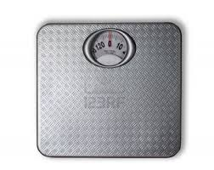

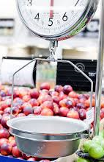
A scale is an instrument for measuring weight. The two main types of scales are spring scales and balance scales. The spring scale is what someone might typically have in a home bathroom. You step on the scale and a spring inside moves a distance that measures the weight. On this type you see an indicator prong that will land on the number of the weight. A spring scale is also used in weight measurements in grocery stores.
Go to Springs and Masses simulation on the PhET site and play around with the sim, trying all the features.

- Explain what happens to Spring 1 if you gently hang the smallest mass (50 grams) from the spring and let it settle to rest. Specifically, where does it hang with the mass compared to without the mass?

- Explain what happens to Spring 1 if you hang the largest mass (250 grams) from the spring. Where does it hang compared to the 50 gram mass?

The scale in the fruit section works by the same principle. A spring stretches and it pulls the needle around the dial depending on how much it stretches.

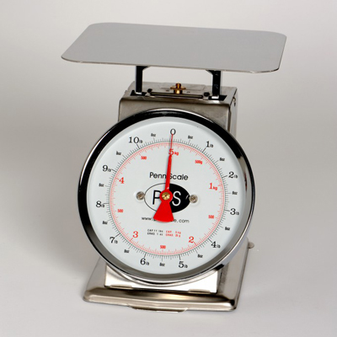
A table top fruit scale works similarly.
The difference is instead of stretching a spring by pulling it down, this type of scale compresses (or squishes) a spring that you cannot see.
A bathroom scale also has a spring inside (a very stiff spring) to measure your weight.

- On Springs and Masses investigate what happens to the rest position of the 100g mass on a spring if you change from the Earth, to the Moon.

- How about from Earth to Jupiter?

- Are these spring type scales measuring weight or mass? Explain why.

- Would these spring type scales measure weight or mass correctly on the moon if it is working properly on earth?

Check your conlcusion for the last two questions above with your instructor
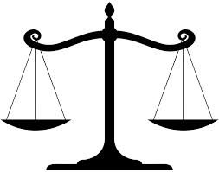
A balance compares one object to another. If they are the same mass/weight then the balance will be balanced. If not, the heavier object’s pan will be lower than the lighter side.
8. Use the balance to determine the mass of your cell phone.

9. Now use the electronic scale to measure your cell phone.

10. If you took this balance and scale to the moon and measured your cell phone. Will you get the same value with each of these devices as you did in lab today? Why do you say this?

Check your conlcusion with your instructor

