Phys 220 – Elasticity of Plastic Spoons
Materials and Equipment: 3 different plastic spoons, clamp, string, spring scale, graph paper, ruler and SAFETY GLASSES
Data Collection
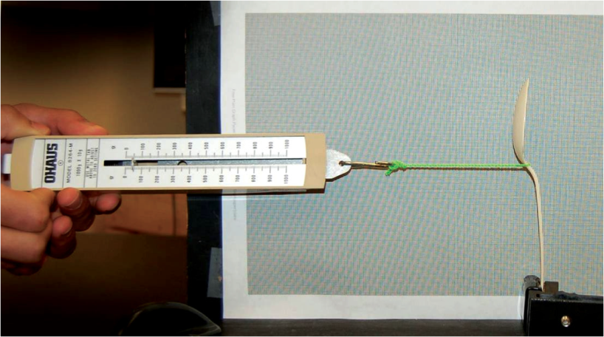
Your job is to carefully measure the displacement of a plastic spoon from equilibrium as an increasingly larger force is applied to the spoon. Increase your force by very small increments and painstakingly measure the displacement as accurately as you can. Take data all the way to the breaking point.
Warning: You must wear safety glasses during this lab!

Analysis
Create a separate graph (scatter) in Excel for each spoon tested. Print all three graphs. Identify on each graph the “linear region”, the “elastic region”, the “elastic limit” and the “breaking point”.
Use the slope** of the linear region of each data set to determine the spring constant of each spoon. Print the graphs.
Identify which type of spoon has a greater spring constant and which has a larger tensile strength.
**Note: to find the slope of a graph in Excel, right click on a data point, choose “Add Trendline” and in the Format Trendline window, click “Display equation on chart”.
Assess
It’s easy to make an error when calculating the spring constant. Look at the data in your graph and make sure that the units of your slope are indeed N/m. Also, try using your experimentally determined spring constant in Hooke’s Law (F = -kx) for a force of 5 Newtons to see if the resulting distance makes sense with your observations. Show this check in your write up.

