**Physics 221**

***Measuring Potentials of the Heart***

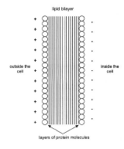**Background**

The rythmic contraction and expeansion of the heart is controlled by a special kind of nervous tissue. This tissue is self-excitable, contracting without any signal from the nervous system, even if removed from the heart and placed in culture. Each of these cells have their own intrinsic contraction rhythm. This property of cardiac muscle tissue is called *automaticity*, or *autorhythmicity*.

A signal that has been initiated by this cardiac nervous tissue, described in the Generation of Action Potentials section, causes a change in the electric field of muscle cells which in turn causes the muscle cells to contract.

Heart muscle cells are polarized at rest. This means the cells have slightly unequal concentrations of ions across their cell membranes. An excess of positive sodium ions on the outside of the membrane causes the outside of the membrane to have a positive charge relative to the inside of the membrane. The inside of the cell is at a potential that is about 90 mV less that the outside of the cell membrane. The 90 mV difference is called the ***resting potential*.**

*The* typical cell membrane is relatively impermeable to the entry of sodium. However, stimulation of a muscle cell causes an increase in its permeability to sodium. Some sodium ions migrate into the cell through the opening of voltage-gated sodium channels.

This causes a change (*depolarization*) in the electrical field around the cell. The change in cell potential from negative to positive and back to negative is a voltage pulse called the ***action potential***. In muscle cells, the action potential causes a muscle contraction.

The effect of this depolarization and repolarization for the entire heart can be measured on the skin surface. Making such a measurement is called an electrocardiogram (EKG of ECG). Since this depolarization of the heart also leads to the contraction of the heart muscles the EKG is also an *indirect* indicator of heart muscle contraction.

**Explore the PhET simulation “Neuron**”.

Although the heart does not contain neurons the demonstration of the resting potential and the action potential are applicable to muscle cells. Both neurons and muscle cells are polarized and will not depolarize on their own without a stimulus.

1. Sodium ions are shown in the sim and discussed above. What is their net charge and what physically has happened to a neutral sodium atom to become an ion?
2. When you stimulate the neuron, how does the net charge on the outside and inside of the cell membrane change with time? Or does it? (Note: you might want to slow the sim speed and zoom in.)
3. If both sodium ions and potassium ions have the same charge, why is it shown that sodium enters the cell and potassium exits? How is the net charge, and hence the potential difference, changing across the membrane when stimulated? (Hint: Do both the sodium gates and the potassium gates open at the same time?)

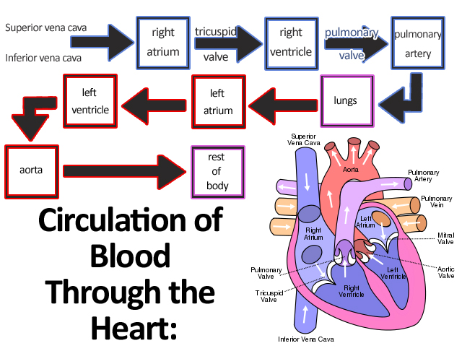**Generation of action potentials**

A region of the human heart called the *sinoatrial (SA) node*, or pacemaker, sets the rate and timing at which all cardiac muscle cells contract. The SA node generates electrical impulses, much like those produced by nerve cells. Impulses from the SA node spread rapidly through the walls of the atria, causing both atria to contract in unison.

[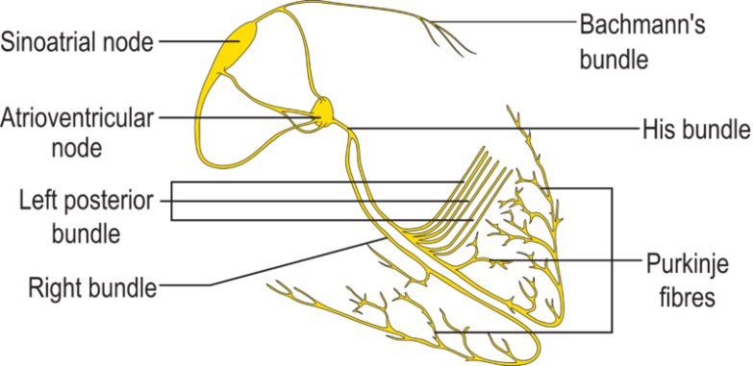](http://upload.wikimedia.org/wikipedia/commons/0/05/ConductionsystemoftheheartwithouttheHeart.png)The impulses then pass to another region of specialized cardiac muscle tissue, a relay point called the *atrioventricular node*, located in the wall between the right atrium and the right ventricle. Here, the impulses are delayed for about 0.1s before spreading to the walls of the ventricle. The delay ensures that the atria empty completely before the ventricles contract. Specialized muscle fibers called *Purkinje fibers* then conduct the signals to the apex of the heart along and throughout the ventricular walls. The Purkinje fibers form conducting pathways called *bundle branches*.

This entire cycle, a single heart beat, lasts about 0.8 seconds. The impulses generated during the heart cycle produce electrical currents, which are conducted through body fluids to the skin, where they can be detected by electrodes and recorded as an EKG.

* 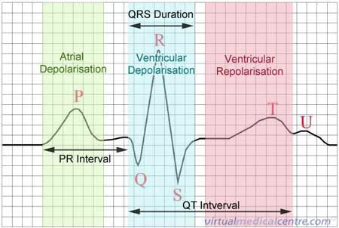The small P wave accompanies the depolarization of the atria. The atria begin contracting around 100 ms after the start of the P wave.
* The QRS complex appears as the ventricles depolarize. This is a relatively strong electrical signal because the mass of the ventricular muscle is much larger than that of the atria. The ventricles begin contracting shortly after the R wave.
* The smaller T wave indicates ventricular repolarization. Note: *The atria repolarize during the QRS complex and therefore this repolarization is not separately measurable.*

**Using An EKG Sensor**

Today you will be using an EKG sensor to measure the potential of your heart. However, be sure to keep in mind that this experiment does not represent a true medical study and that reading an EKG effectively takes considerable medical training and skill. Therefore, do not be alarmed if your data or graphs seem “different” from those of your partners.

a. Using a paper towel, scrub the area inside each elbow and the inside of the right wrist.

b. Obtain three electrodes per group member from your lab instructor. Electrodes for this lab are limited and cannot be reused so once you apply them, leave them in place until you have completed lab.

c. Firmly place the electrodes on your skin - one on your right wrist, one on the inside of the right elbow, and one on the inside left elbow (as pictured).

d. Connect the sensor to the electrodes. The reference (black) lead should be connected to your wrist. This lead will be the “flat line” potential on your EKG. The positive (red) lead should be connected to the electrode on your left elbow. Finally the negative (green) lead should be connected to the electrode on your right elbow. Try to adjust the wires so that they are not twisting or pulling on the electrodes.

Very few students may react to the electrodes. For example, you may have an allergy to the substance on the electrodes. If you feel a burning sensation or are extremely uncomfortable, then remove the electrodes immediately and rinse the area. You can finish the lab by using one of your lab partner’s data to answer all questions.

**!**



**EKG Studies**

Each member of your group should complete this experiment and analyze their *own* data.

Once you are connected to the EKG sensor, then relax, remain still and breathe normally. Someone else should operate the computer while data is collected for your heart.

The data should be collected for eight seconds.

Once you have collected a “good” set of data, then save and print your results and start the next person in your group.

Disconnect the EKG sensor from the electrodes, but **leave the electrodes attached to your arms**.

**Analyzing Your Data**

Using your data, answer the following questions for your heart. Explain how you make any measurements or any calculations that you do. You must justify all answers.

1. What is the peak-to-peak value of the voltage between the R wave and the S wave?
2. What is the P-R time interval?
3. What is the Q-R-S time interval?
4. What is the Q-T time interval?
5. What was the frequency of your heart during the testing (in *beats/min* and *Hz*)?
6. What would happen if you switched the red and green leads? Try it out experimentally and make a sketch below. Explain any differences that may occur due to this change.

**EKG After Mild Exercise**

Each member of your group should complete this experiment and analyze their *own* data.

Once each member of your group has completed their own EKG and printed their graph, then you are ready to study the effect of mild amounts of exercise on your EKG. Each member of your group should complete this experiment.

One at a time, you should stand up and exercise for three minutes (jog in place, “step in time”, walk up and down the stair case, walk briskly around the hallway, ...).

After the three minutes are up, then sit back down and get reconnected to the EKG sensor as quickly as possible. Collect a new set of data.

1. Briefly describe the exercise that you completed.
2. Answer questions 1-5 for this new data set.
3. What effect did the exercise have on your EKG? What things seemed unaffected?

**Concluding Questions**

1. In your own words, explain the purpose of the “goop” that is on the electrodes.
2. Based on the data collected in your lab group, what is an “average” amount of time between the start of depolarization of the atria and the start of the depolarization of the ventricles for a human heart?
3. Based on the data collected in your lab group, what is an “average” amount of time required for the depolarization of the ventricles and the subsequent ventricular repolarization for a human heart?