Ultimate Egg Launch

Materials: 1. Launcher, 2. 1.5 liter bottles, 3. Eggs (not hard boiled), 4. Junk from the dollar store/ drug store/ stock room. For our junk we used sponges, balloons, napkins, Styrofoam cups, plastic wrap, zip locks, straws, string, paper plates, popcorn, newspaper, pipe cleaners, tape, shower caps, all purpose anti-slip grip lining.
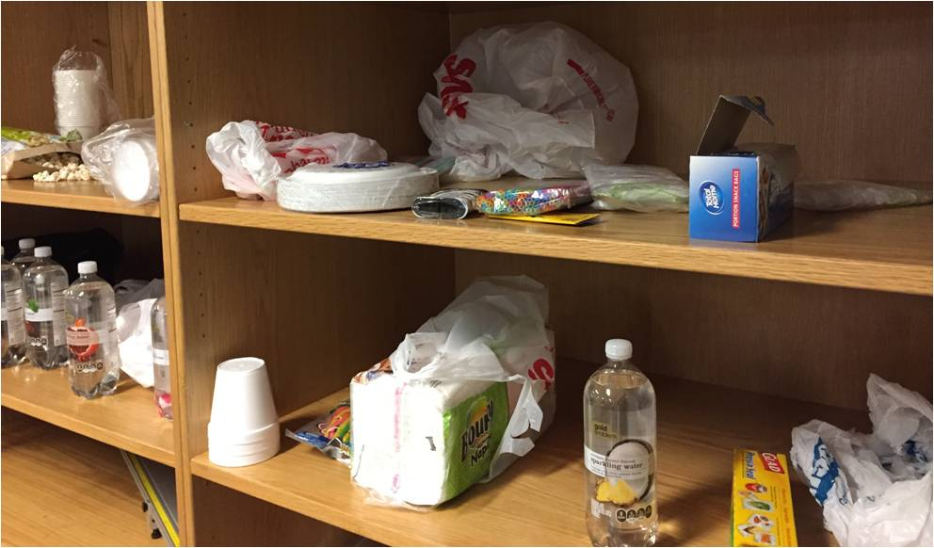

The 1.5 liter bottle is the engine. The mouth must be free to slide over the launcher. Students are allowed to build whatever they want to protect their egg but it must be attached to the engine (loosely is fine). Photo of launcher on next page.

