Ball in the can
Instructor directions:
Materials: Pasco Physics String or Dacron fishing line, Sewing thread, paperclips, cutter, and golf ball with small hole drilled top and bottom so a thread can go through it. The cutter can be a razor blade glued into a plastic slider (just for convenience and safety) or could use razor blade attached to a ruler (be very careful when not in use).
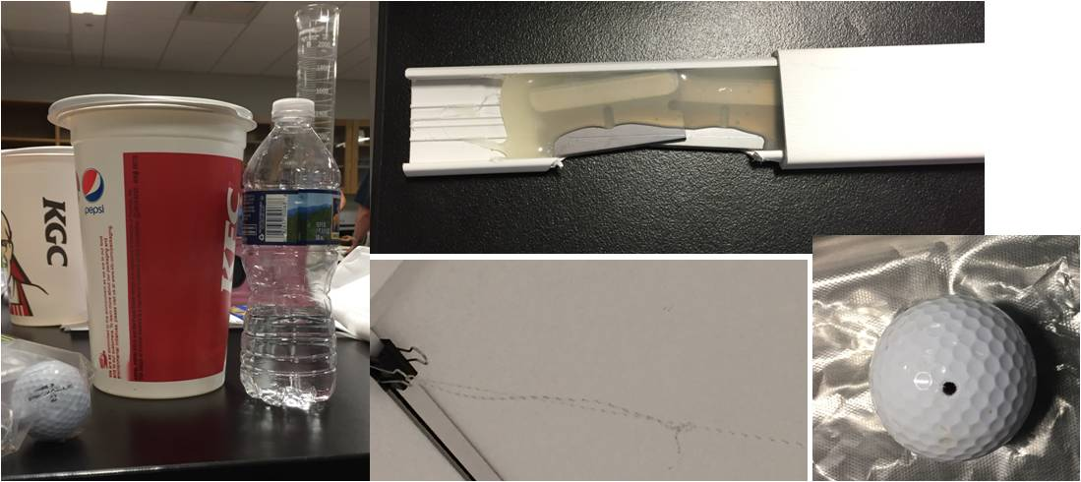
Note: You can substitute taping the ball to the string with lots of tape if you don’t want to drill a hole
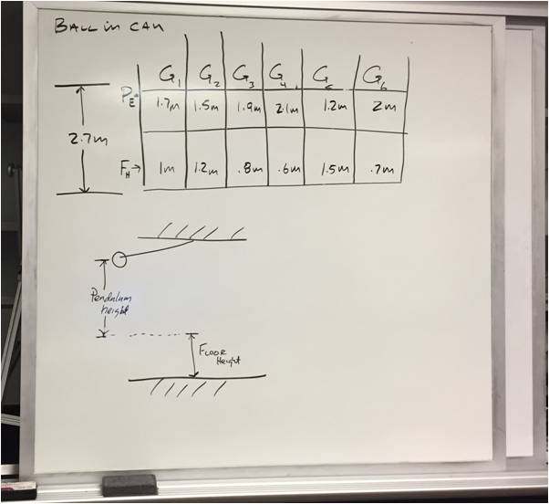
Set up:
- Attach a length of either Pasco Physics String or Dacron fishing line from the ceiling for each group. The length you need is a function of the ceiling height in your room. See table below to figure out what you’ll need.
- Give each group a paper clip, sewing thread, and golf ball.
- Provide each group a different height off the floor and height from ceiling. All floor plus ceiling heights equal the distance from ceiling to floor. For example if it is 2.7 m from the floor to the ceiling, 1.2m from the floor plus 1.5 m from the ceiling = 2.7 m.

- They should put the thread through the golf ball and use the paper clip on the bottom to hold the ball up at their group’s assigned height. Attached the thread to the Dacron string via a paperclip or fishing swivel.
- Students calculate where the cup needs to be for the ball to land in it. When ready, instructor comes over to help students set up the razor and then instructor releases the ball.
Click here to see a video
Notes:
- The hardest distances are the ones that are the closest to the floor so give those distances to your strongest kids. Keeps them busy while others are working.
- Can give 15 extra credit for first time, 10 for 2nd time and 5 for 3rd time.

Student Directions:
We verbally describe the challenge, write the distances on the white board and let them go. It’s best not to give them too many specific instructions, they’ll all figure it out their own solution.

