**Physics 221**

**Fun with DC Circuits**



The field of electronics has revolutionized the way we live and what we do. We can find circuits everywhere—from our cell phones, digital watches, calculators, televisions, computers, etc. Understanding how these things work is interesting in their own right, but from this we can figure out how to do more practical things, like design and install our own car stereo system and work safely with electricity.

In this lab, we will first look at a few simple DC circuits that will give us an idea of how these things work in the first place. We will learn how to use an electrician’s best friend—a digital multimeter (DMM).



**The Tools:**

On your table:

Batteries, bulbs, wires, resistors and a digital multimeter.

The hand-held digital multimeter (DMM) is a wonderful little device which can be used to measure the voltage difference between any two points in a circuit, the current, and the resistance or capacitance of any circuit component(s). In this lab, we will use the DMM to measure both resistances and DC voltage differences. In this lab, all measurements will be DC, so when measuring voltage, use DC V settings.

The 2 wires attached to the DMM are called probes. You can quickly measure the change in voltage between any two points in a circuit by touching the points with the needle probes.

When measuring a resistance with a DMM, you must disconnect the source of the resistance from any other devices, such as power supplies. Never try to measure the resistance of a resistor while it is still in a circuit.

The Circuit Construction Kit (CCK) Simulation:  
With the CCK you can quickly build and explore any circuit you want.

It comes with:

* batteries with adjustable voltages
* light bulbs with adjustable resistance
* resistors with adjustable resistance
* switches
* wires
* [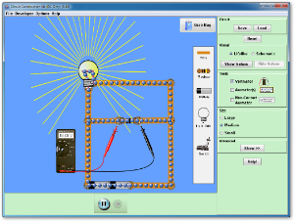](http://phet.colorado.edu/sims/circuit-construction-kit/circuit-construction-kit-dc_en.jnlp)a volt meter which like the DMM can measure voltage differences between any two points in your circuit.
* and, a current meter

**PART I: UNDERSTANDING RESISTANCE**

Your goal of this part of the lab is the following: *Figure out how to measure the resistance of various things using the tools in the CCK.*

Equivalent Resistance in Series: RTot = R1 + R2

Equivalent Resistance in Parallel: $\frac{1}{R_{Tot}}= \frac{1}{R_{1}}+ \frac{1}{R_{2}}$

In your play area select 5 resistors and adjust their values to be: one 1Ω, one 4Ω, two 20Ω, one 50Ω. Add two light bulbs to your play area and adjust their resistance to be 25Ω.

It is up to your lab group to create 3 different resistor combinations using some of the 5 resistors and 2 light bulbs —both in series and in parallel.

Show an example here

1. Draw a picture of each combination of resistors and *predict* the equivalent resistance of that combination.
2. Build these resistor combinations in the CCK, and test your prediction by building another single-resistor circuit with the equivalent resistance and comparing the two. Do your two circuits have equivalent resistance? How can you tell? **Check with your Lab Instructor after you test your first circuit to verify your method.**
3. Describe any corrections you had to make to your predictions for equivalent resistance of each circuit in 1. above after testing your circuits in CCK.

**PART II: CIRCUIT BEHAVIOR**

Using CCK, construct the circuit shown to the right, consisting of two light bulbs in series with the power supply (battery). (***The resistor R will be added later****).* Slowly increase the battery voltage until the bulbs are glowing, but not too bright.

1. *Predict* what will happen to the brightness of the bulbs when you place a 50Ω resistor in parallel with bulb #2 as shown in the schematic.
2. Add in the resistor, and describe what happened and why.
3. Measure the voltage difference across the light bulbs and resistor. Show explicitly how the voltage difference across each light bulb, the resistor and the battery voltage are related.

Complete steps 1 – 3 for other resistor values and describe what happens in each case.

**PART III: REAL EQUIPMENT CIRCUITS**

Build the circuit in Part II with real batteries and lightbulbs. **Have your lab instructor check that your circuit is wired correctly.**

1. Measure the resistance of one of your lightbulbs and record it.

Locate a resistor that is approximately 50Ω. Use the DMM to measure the actual resistance of this resistor.

1. Predict how adding the ~50Ω resistor to your circuit will affect the brightness of both bulbs.
2. Now add the ~50Ω resistor to your circuit as shown in Part II. Describe what happened and why.
3. Measure the voltage difference across the light bulbs and resistor. Record the results and show explicitly how the voltage difference across each light bulb, the resistor and the battery voltage are related.
4. Repeat steps 1 and 2 for a resistor that is approximately 4Ω.

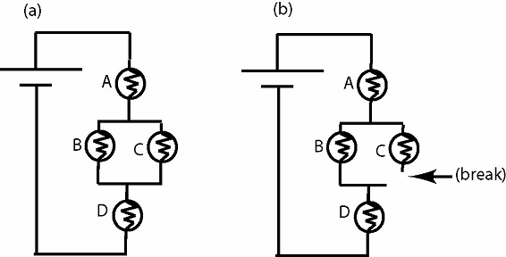**PART IV: REAL EQUIPMENT CHALLENGE**

Locate a second set of lightbulbs and build the circuit shown in (a) of the figure to the right. Once you’ve successfully created this circuit, **have your lab instructor verify that it is correct**.

Make a break in the circuit as shown in (b).

EACH PERSON is to describe in 50 words or **more**, what happens and WHY the bulbs change brightness as they do. You may use words and formulas. Present your reasoning in everyday language so that a friend who has never taken physics would understand your reasoning for why you ranked the bulbs as you did.