Phys 220 – Rotational Equilibrium/Center of Mass

Materials and Equipment: meter stick, hanging masses, lab stand, string, metal forks, glass of water, tooth pick, cork, matches
Procedure:
- Suspend the meter stick from its center of mass.
- For each combination below
- calculate the unknown position,
- determine the position experimentally, and
- determine percent error between the calculated and experimental values.

- If a 350g mass is placed at the 70cm mark, where should a 150g mass be placed to keep the meter stick in rotational equilibrium?
- If a 100g mass is placed at the 90cm mark and a second mass is placed at the 20cm mark, what should the second mass be to keep the meter stick in rotational equilibrium?
- In 2, above, add 50g to each mass at its current location. Determine whether the meter stick is still in rotational equilibrium.
- If a 20g mass is placed at the 70cm mark and a 300g mass at the 90cm mark, where should a 500g mass be placed to keep the meter stick in rotational equilibrium?

Now suspend the meter stick from the 30cm mark.
- If a 400g mass is placed at the 10cm mark, where should a 200g mass be placed to keep the meter stick in rotational equilibrium?

Question
- Why are tire irons longer than a normal wrench?

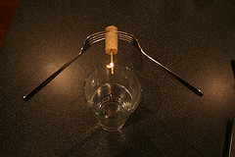
Challenge - Balancing Forks
Materials: two metal forks, wine cork, tooth pick, matches, glass of water.
- Set up the forks, cork and tooth pick as shown in the photo to the right.
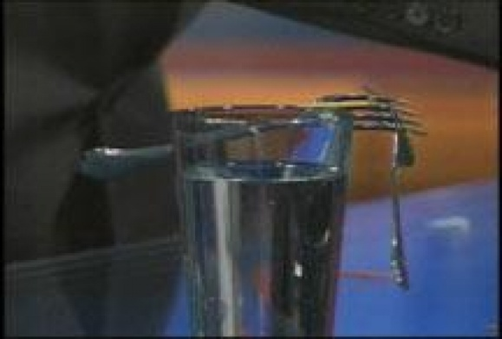
- Once the toothpick is balanced on the edge of your cup of water. Light the match on fire and see if it causes the fork/cork combo to fall off the cup.
Explain
Explain in detail using the concept of center of mass, why and how this trick works.
Extra Credit
Balance two forks using only the toothpick as shown in the picture to the right.

Friction Meter Stick
Materials: Meter Stick , Variety of Weights
Procedure: Using both index fingers, place hands at opposite sides underneath the meter stick. Move fingers together at the same pace and note that they meet up at the center of mass; the stick is perfectly balanced.
Now add a weight to one end and perform the demonstration again. The center of mass will have shifted in favor of the weight but the stick will still be perfectly balanced. Experiment with various amounts of weights at different points. The meter stick will always remain balanced.
Explanation
Use physics that you’ve learned this semester to explain why this works!

