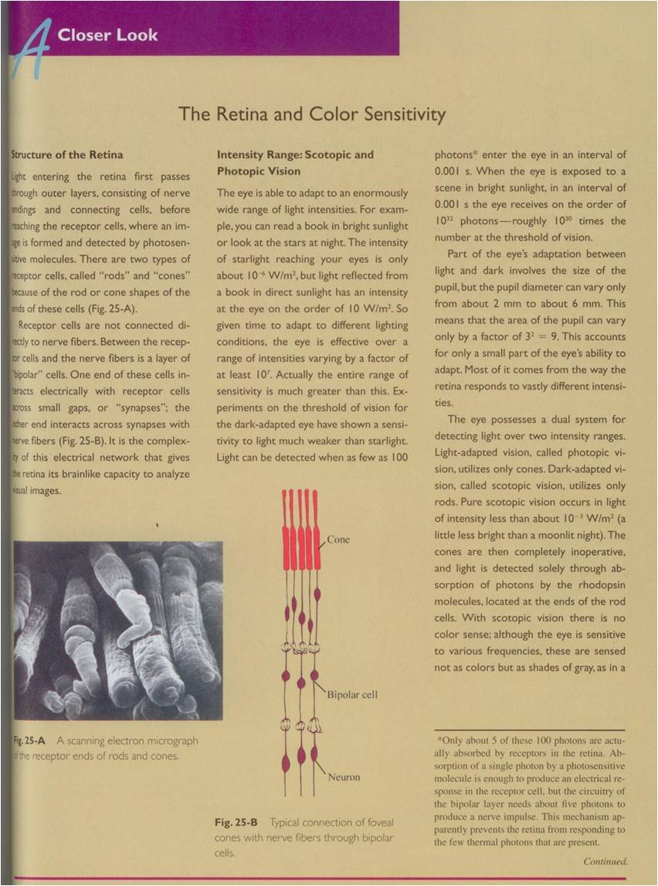
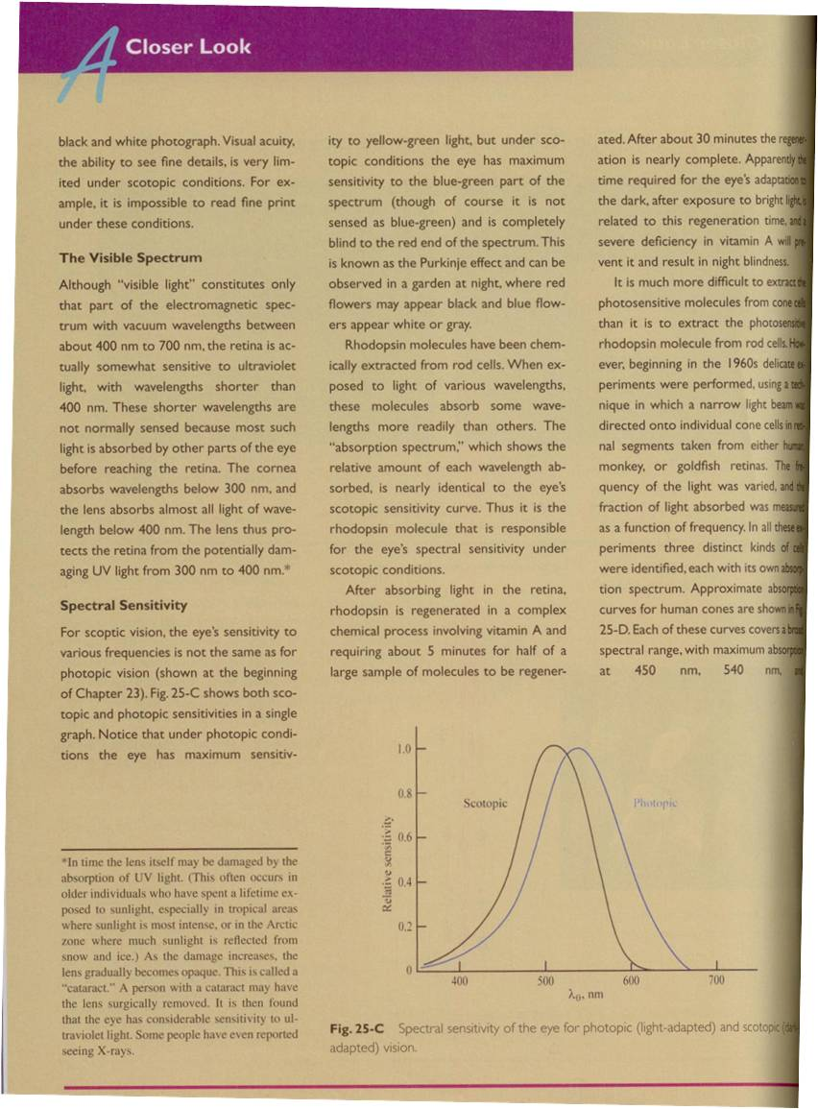

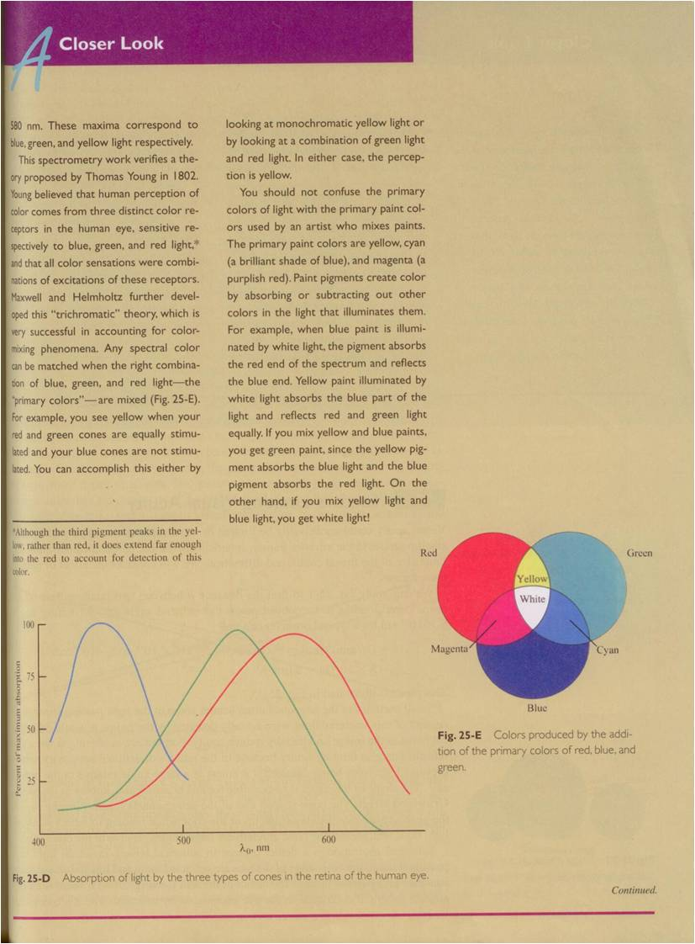

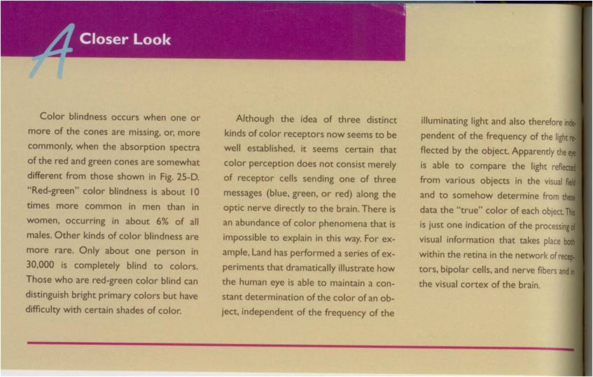
- Look at the picture of cones and rods. Do cones look like you expected? Why? Have you seen an image of cones and rods before? If so where?
- Is the sensitivity range of our eyes as phenomenal as the range for our ears? What are you basing this answer on?
- What is scotopic vision?
- What is photopic vision?
- Sit in a dark room (no more light than moonlight) for 5+ minutes and then make some observations. Are you able to see detail of objects around you, can you identify colors, are you comfortable functioning at this level of light? Do your observations match the article, why or why not?
- Now try reading normal size text. Are you able to do this after sitting in the room for 5+ minutes?
- Why do questions 4 and 5 ask you to sit for 5+ minutes before making your final observations? Be very specific in your answer.
- Does the sensitivity of our three types of cones appear to be equally spaced across the visible spectrum? Explain? Does this fit with the description in lab about the fovea not containing blue cones? Why?

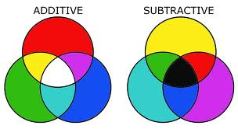

- Consider primary colors of light and primary paint colors. The colors on the right are demonstrating subtractive color combinations which are used in art. For example, red and green make black. However, when considering how light combines, additive combinations, you can see that red and green make yellow!
Use page three to fill in the following table to see how this works:
Color / substance | Absorbs | Reflects
Blue paint
Yellow paint
Yellow and Blue paint mixed
Yellow and Blue light

