Physics 221 – Spring 2012
Quiz #2
This is a group quiz
Names: ______Solution______________

- Compare and Contrast the Doppler Effect and a Sonic Boom.
  - Do the actual sounds heard have something in common?
These are two distinct sounding phenomena. The Doppler Effect is when you hear a higher frequency as an object is approaching and a lower frequency as it is receding compared to the frequency being emitted by the source. With a Sonic boom, you hear and very loud sound all at once (boom for a jet or a crack from a whip) as the disturbance in the air passes by you which is caused by an object traveling faster than the speed of sound.
  - How about the underlying physics, how closely related are they (use diagrams to support your answer)?
The physics of each is actually quite similar. With the Doppler effect since there source is approaching an observer, each wavefront is emitted closer to the observer than the last. This causes the received wavelength to be shorter and the receiver then hears a higher pitched sound. Vice versa if the source is moving away. A sonic boom happens because the source is moving faster than the sound waves so each wavefront is emitted beyond the distance the previous wavefront has managed to travel. A cone is created trailing the object where the wave fronts overlap. This overlap creates a huge disturbance in the air and that disturbance is the sonic boom.

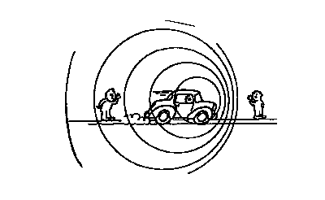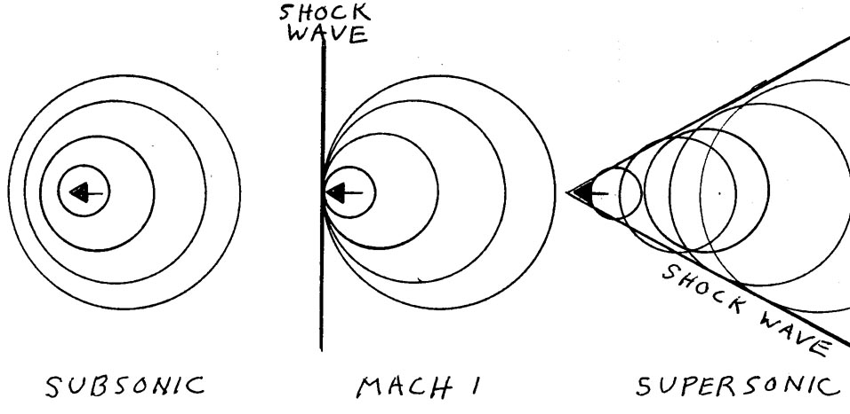

- A particular speaker at a concert puts out 110 Watts of power.
  - Calculate both the intensity and the intensity level at 1 meter.
Intensity: I = $\frac{P}{4πr^{2}}$ = $\frac{110 W}{4π{(1m)}^{2}}$ = 8.75 W/m² ,
Intensity Level is decibels β = 10 log ($\frac{I}{I_{o}}$) = 10 log ($\frac{8.75 W/m^{2}}{1 x {10}^{-12}W/m^{2}}$) = 129 dB

  - Determine how far you must stand from the speaker to receive an intensity level equal to the threshold of pain (120 dB)?
120 dB = 10 log ($\frac{I}{1 x {10}^{-12}W/m^{2}}$) solve for I by dividing by 10 and then placing both sides as exponents of 10. 10^{log(x)} = x. 12 = log $\frac{I}{1 x {10}^{-12}W/m^{2}}$ now 10¹² = $\frac{I}{1 x {10}^{-12}W/m^{2}}$ so I = 1 W/m²
Now use your new Intensity (1 W/m² ) to find r the distance.
I = $\frac{P}{4πr^{2}}$ = 1 W/m2 = $\frac{110 W}{4π{(r)}^{2}}$ r = 2.96 m

  - How far must you be for the sound level to be 80dB?
80 dB = 10 log ($\frac{I}{1 x {10}^{-12}W/m^{2}}$) solve for I by dividing by 10 and then placing both sides as exponents of 10. 10^{log(x)} = x. 8 = log $\frac{I}{1 x {10}^{-12}W/m^{2}}$ now 10⁸ = $\frac{I}{1 x {10}^{-12}W/m^{2}}$ so I = 1 x 10⁻⁴ W/m²
Now use your new Intensity (1 W/m² ) to find r the distance.
I = $\frac{P}{4πr^{2}}$ = 1 x 10⁻⁴ W/m2 = $\frac{110 W}{4π{(r)}^{2}}$ r = 296 m

- On a very cold day, -10ºC, you are driving down the road at 15 m/s and you see a car that is honking its horn. You have perfect pitch so know you hear exactly 457 Hz. It’s a blizzard so you are having a hard time telling if the car is moving, much less if it’s moving towards or away from you. Since you also happen to know that this particular make of car puts out a frequency of 425 Hz from its horn, you are able to quickly determine if the car is heading towards or away from you and you are great with numbers and in your head determine the car’s exact speed.
  - Is the car moving towards or away from you?
You hear a higher frequency than the source puts out so the two cars are getting closer. Because the frequency change is fairly large, the car must be approaching you as well.
  - What is its speed?
f’ = f $\frac{v±v_{o}}{v±v_{s}}$, f’ = 457 Hz, f = 425 Hz, v_{o} = 15 m/s, v_{s} = ?, v = speed of sound in air at -10º
v = 331 m/s $\sqrt{1+\frac{-10}{273}}$ = 324.9 m/s 457 Hz = 425 Hz $\frac{324.9+15}{324.9- v_{s}}$ , 1.075 (324.9 – v_{s}) = 324.9+15, v_{s} = 8.7 m/s

Equations

f’ = f $\frac{v±v_{o}}{v±v_{s}}$, + observer moving towards, - observer moving away, - source moving towards, + source moving away.
v = 331 m/s $\sqrt{1+\frac{T}{273}}$ I = $\frac{P}{4πr^{2}}$ β = 10 log ($\frac{I}{I_{o}}$) I_{o} = 1 x 10⁻¹² W/m²

