Exam 2
Physics 221
Name: _________________________

- ( 10 pts) Explain why it doesn’t make sense to use both the near point and the far point of a particular eye in the same lens equation.

- (10 pts)
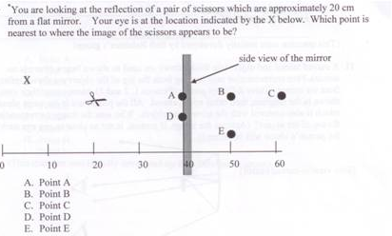

- (15 pts) Explain what type of mirror is typically used on the passenger side of a car (converging or diverging). Explain why this type is used and why, in particular, the other type would not be safe. Use diagrams if it’ll help clarify your explanation.

- (20 pts) Consider diamond which has an index of refraction of 2.42 and air which has an index of refraction of 1.0.
  - Will there be a critical angle when light goes from air to diamond? How about from diamond to air? Why?
  - Calculate the critical angle.
  - Draw a diagram indicating a light ray incident at an angle just over the critical angle and a second ray that is incident at an angle just under the critical angle.

- (20 pts) A person has a far point of 50 meters (5000 cm) and a near point of 1.5 meters (150 cm).
  - What sort of correction does this person need? Why?
  - Find the prescription for the appropriate contact lenses.
  - Draw a scale ray diagram of the lens with an object that produces an image at his uncorrected near point of 1.5 meters.

v = λf E = hf h = 6.63 x 10⁻³⁴ J/s c = 2.998 x 10⁸ m/s
Law of Reflection: θ_{i} = θ_{r} Snell’s Law: n₁ sin θ₁ = n₂ sin θ₂ sin θ_{c} = n₂ /n₁

