Why Mosquitoes Buzz in People’s Ears
Bill Reitz

This activity integrates literature into a science lesson about how vibrations cause sound.

The lesson is based of the book Why Mosquitoes Buzz in People’s Ears by Verna Aardema, which is a West African Tale, making the lesson easily tied in to a social studies lesson. It is also appropriate for discussing folktales and cause and effect.

Science Topics | Process Skills | Subject Integration | Grade Level
Vibrations make sound | Observing  Scientific Inquiry  Comparing | Literature  Social Studies  Life Science  Physical science | 1-6

Time Required
Advanced Preparation | Set-Up | Activity | Clean-Up
minutes | minutes | 45 minutes | minutes

Learning Goals

Students will be able to:
- Create a mosquito buzzer using the required materials
- Be able to describe why people hear mosquitoes buzz
- Design and test an experiment that tests one of the factors

Materials
- Why Mosquitoes Buzz in People’s Ears by Verna Aardema, pictures by Leo and Diane Dillon
- Buzzer Instructions (Optional) (page 6-7)
- Mosquito Buzzer (one per person)
  - Mosquito Picture on cardstock (page 5)*
  - Tongue depressor
  - Rubber band (assorted rubber bands in various thicknesses)
  - String 1.5 meters in length
  - 2 small pieces of Styrofoam –or- Corrugated cardboard rectangles
- Tools to Make the Buzzer
  - Scissors
  - Hot glue sticks
  - Hot glue gun
  - Stapler and staples
- Notebook or paper
  - Optional handout for younger grades (page 8)
- Additional Resource on Mosquitoes

*This is an 8.5x11 sheet of 6 mosquito buzzers.

Advanced Preparations

- Gather materials
- Depending on the age of your students and your time limit, you may want to cut the mosquitoes out ahead of time

Set Up
- Prepare materials to hand out to students

Introducing the Activity

Explain that students will be reading a book about Why Mosquitoes Buzz in People’s Ears, then will be conducting an experiment about what makes mosquitoes buzz.

Read Aloud
- Read the Book to find out why mosquitoes buzz in people’s ears
- Discuss the book. Some ideas for discussion are:
  - Discuss the cultural significance of the book. This might be a good place to talk about folk tales.
  - Do you think this is why mosquitoes buzz in people’s ears? Are mosquitoes purposefully buzzing in your ears?
  - If a mosquito was on the wall 5 feet away, do you think you would hear it?
  - How do you think mosquitoes make the buzzing sound?

Doing the Activity

Construct the Mosquito
See instructions on page 6 for pictures.
- Cut out the mosquito image
- Staple the mosquito image to the tongue depressor with the bottom of the mosquito lined up with the bottom edge of the tongue depressor. Place one staple on each side of the picture. Under the left hand staple, place the piece of string
- Double knot the string around the staple
- Hot glue one piece of either styrofoam or cardboard on each end of the tongue depressor.
- Stretch a rubber band around the tongue depressor.

Activity

- Students should form small groups and will move to the indicated are and whirl their mosquito to hear it buzz
  - To use the buzzer, they should wrap the end of the string around their hand twice
  - They can either whirl it in front of them or above their head
- In their notebook (or paper) students should brainstorm possibilities of what factors affect how the Mosquito buzzer sounds.
  - They should consider each part of the mosquito buzzer and what affect it may have in making the sound.
- Each group should choose one of the factors to experiment
  - They will design and perform and experiment that determines how that factor affects the ‘buzzing’ sound.
Note: Science should be fun! It’s okay for students to change their plan once they’ve started working, especially if they’ve realized their idea won’t work. It’s all a part of learning to be a scientist.

- Students will have access to additional materials, and can make additional buzzers with appropriate changes to vary the facto they’re testing.
- They should write their procedure, data, and results in their notebook.

Presentation
- Each group will share their findings with the rest of the class.
- They should describe the process to their findings, and describe if they had a plan, and if they had to change it at all.

Class Discussion
- As a class, discuss why the mosquito buzzers make a buzzing sound.
- Have a class discussion about what makes mosquitoes really buzz.
  - How is the mosquito buzzer similar to actual mosquitoes?
- For more information, visit Mosquito Reviews to find out more information about mosquitoes, such as why they actually buzz in your ear.

Explanation
In-depth background information for teachers and interested students
Key Terms:
- Vibration – a shaking back and forth movement

Optional Extensions /Modifications

Modifications:
- Some students may need additional help constructing their mosquitoes
- If students don’t have the writing skills to write in their journals they could draw their ideas and give verbal reports without writing anything down.

Optional Extensions:
- Some students may have made the size of their mosquito the factor they changed. Discuss how a smaller mosquito makes a higher pitch sound and larger mosquitoes make lower pitched sounds. Discuss how males are smaller than females, and therefore have higher pitched whines.

- Play with tuning forks! Tuning forks and mosquitoes create sound in the same way, and can have the same vibrations.

- As you age you lose the ability to hear higher frequencies. This could lead to an activity about how young children can hear higher sounds, and could lead to an activity about how loud sounds affect your hearing.

- This book and activity could lead into lessons about folk tales from around the world.

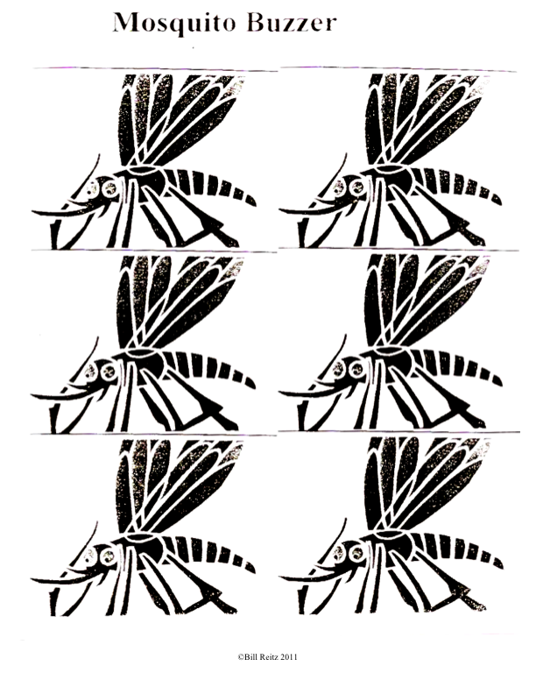

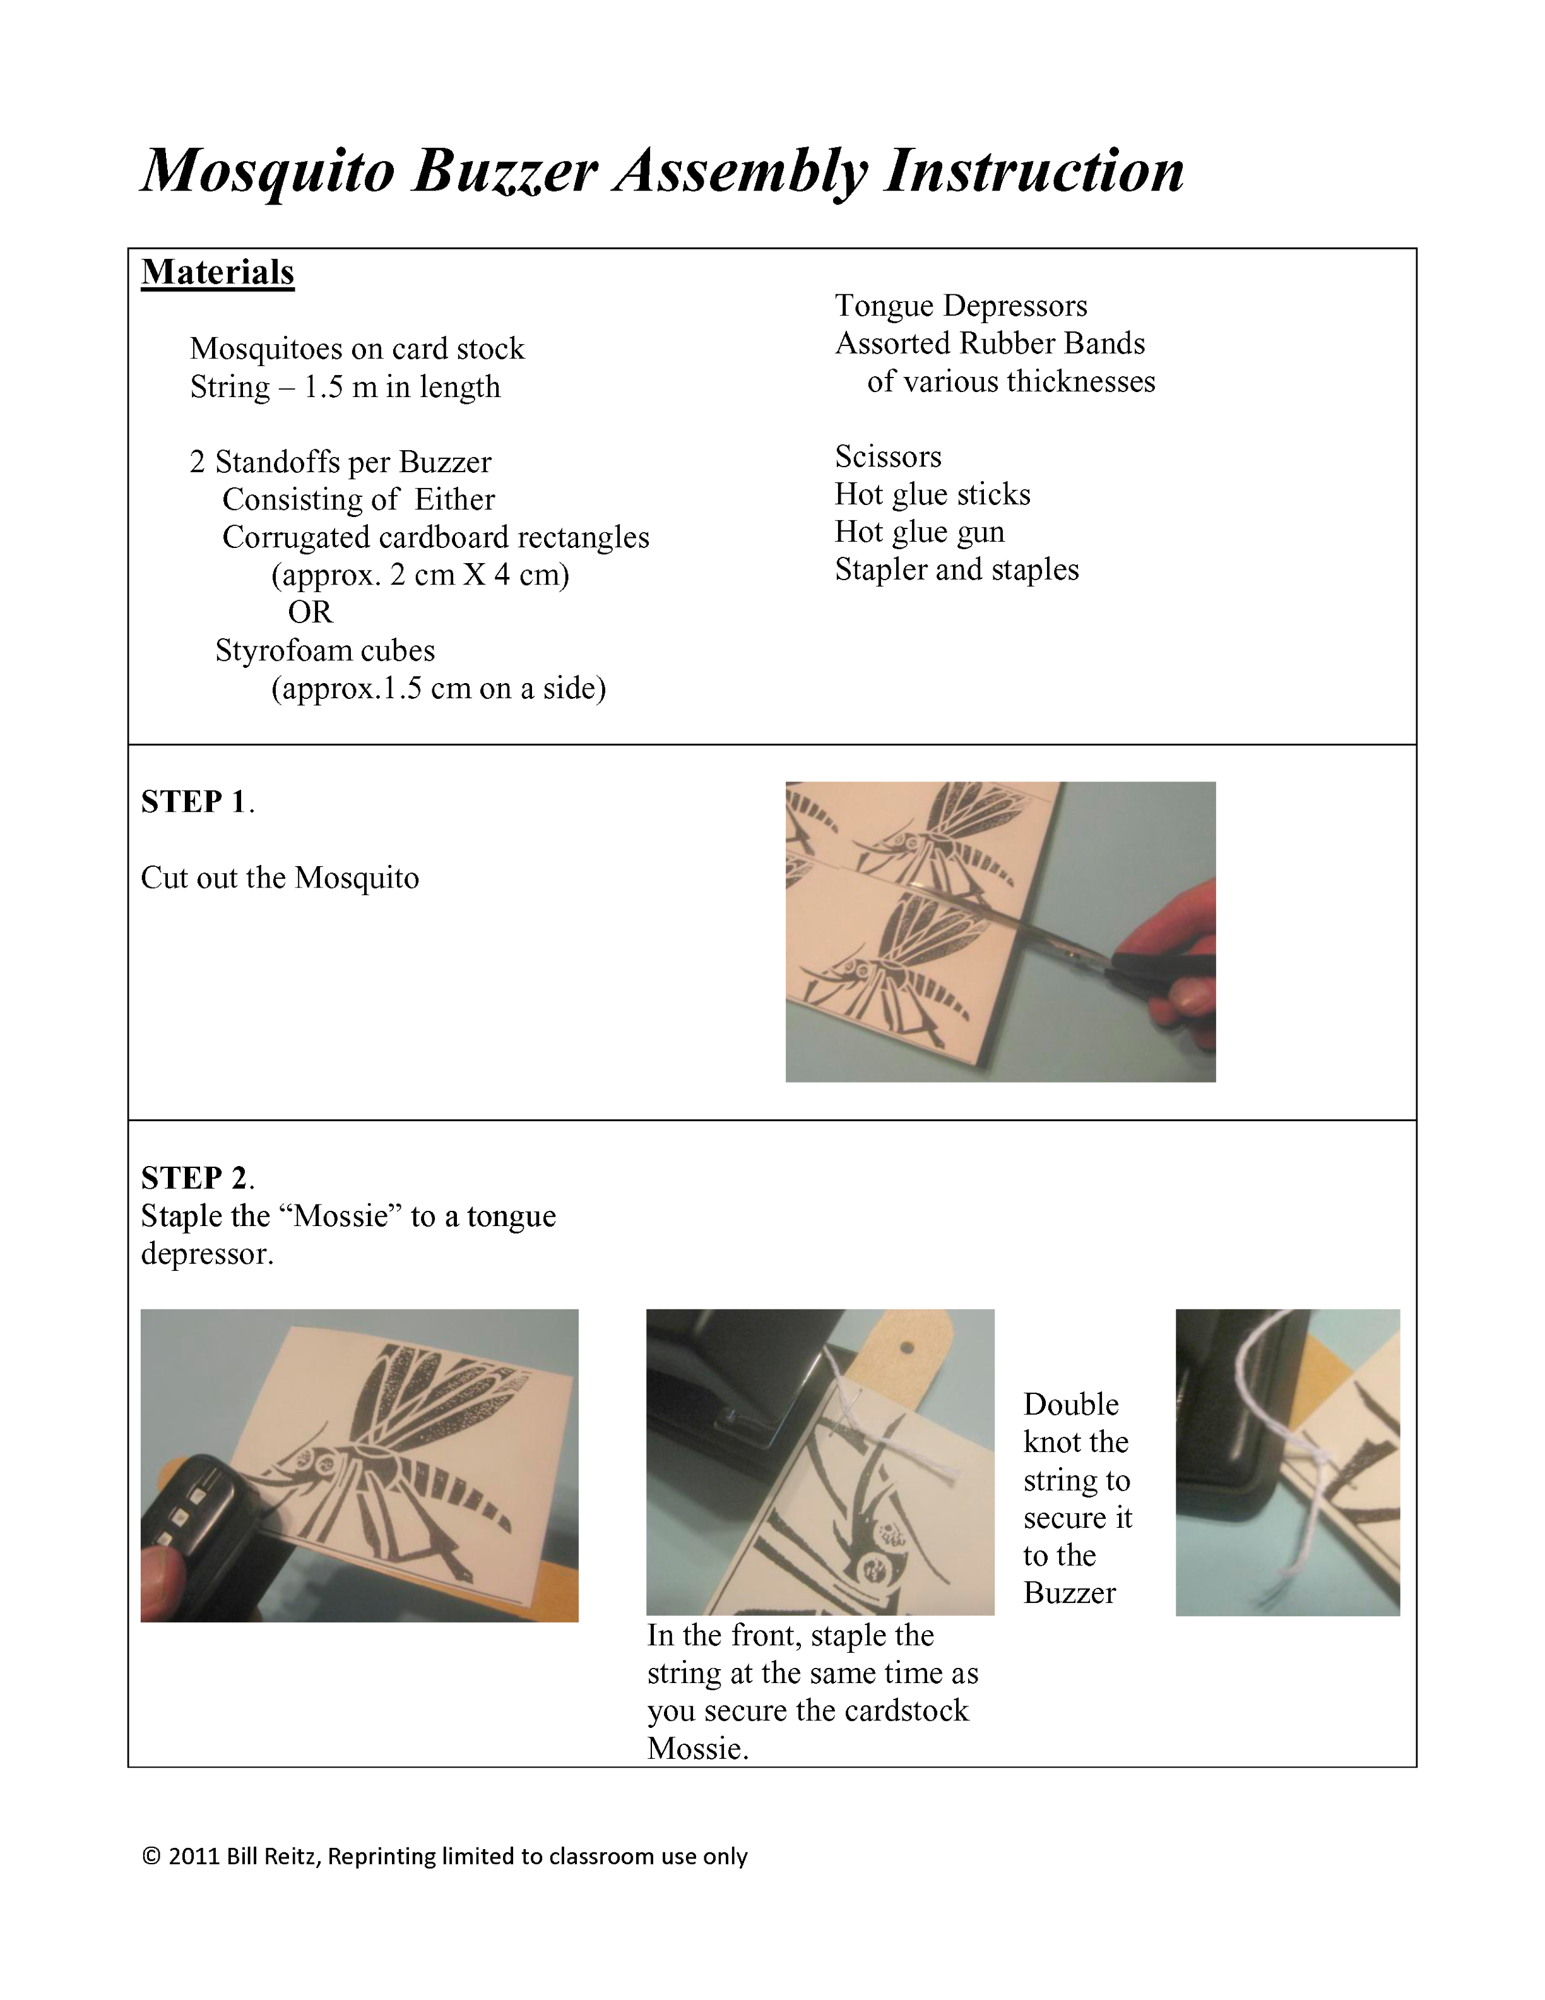
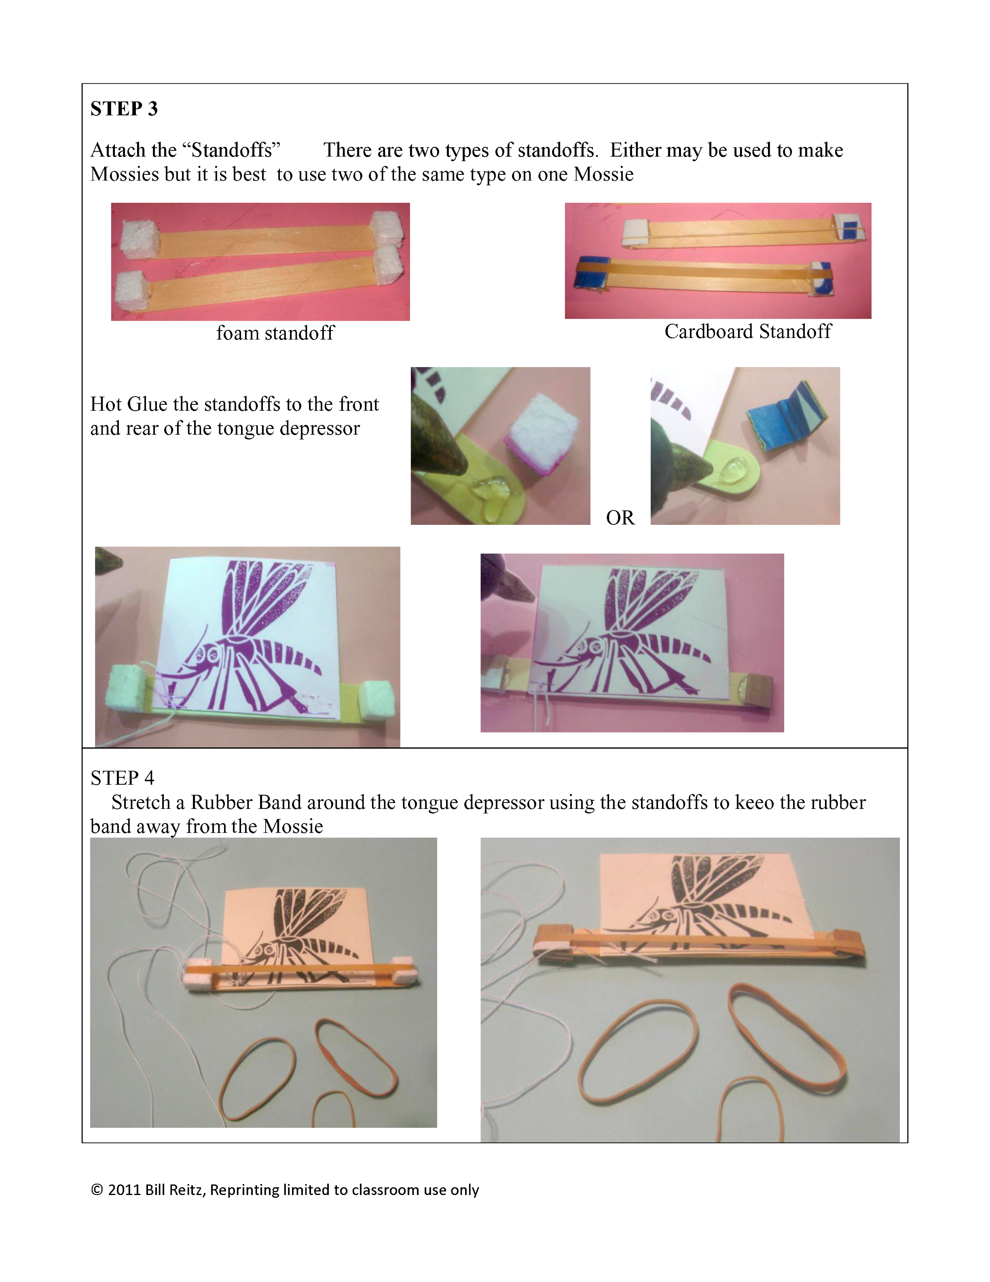
Name _______________

Why Mosquitoes Buzz in People’s Ears

- Construct your mosquito buzzer
- Whirl your mosquito to hear it buzz

- What factors might affect how the mosquito buzzer sounds? Brainstorm your list below:

- Choose one of the factors above to explore and write it on the following line: __________________

- Design an experiment to test how the factor you chose affects the buzzer sound. Talk to your group about how you’ll make these changes.

Discoveries!
Write down how the changes you made to your mosquito affects the sound it produces.

What was your plan? Did you have to make changes to your plan as you went?

