**Physics 221 – Simple Harmonic Motion**

**Procedure:**

Your task today is to experimentally answer the questions posed for three simple harmonic oscillators: mass on a spring, simple pendulum and pasta with raisins.

* Your write up must include an answer to each question theoretically (according to the equations), and why you think this.
* Your write up must also include a clear description of how you experimentally answered these questions written so that a fellow classmate who has not done the lab, could reproduce your results exactly!
* Include data.
* Your results must be convincing, which means one example will not adequately support your answer.

1. **Mass Attached to a Spring**

The motion of a mass attached to a spring is *simple harmonic motion* if:

1. there is no friction and
2. if the displacement of the mass from its equilibrium position at *x* = 0 is “small”. The displacement must be small enough so that the spring is not stretched beyond its elastic limit and becomes distorted.

The period of a spring/mass system undergoing simple harmonic motion is described by:

*T* = 2 , notice *T* and *m* are not linearly related.

Period and frequency have the relationship*, T* = 1/*f*

**Materials and equipment available**: big spring, weight hanger, masses, stop watch, motion detector, and Logger Pro interface and software.

1. ***Does the period of the motion depend on the amplitude?***
2. ***Does the period of the motion depend on the mass?***
3. **Simple Pendulum**



The motion of a pendulum can be treated as simple harmonic if:

1. there is no friction and
2. if the displacement of the mass *m* from the equilibrium position is small,  ≤ 15o

The period of a pendulum undergoing simple harmonic motion is described by:

*T* = 2 , notice *T* and *L* are not linearly related.

Period and frequency have the relationship*, T* = 1/*f*

**Procedure**

Materials and equipment available: masses, string, stopwatch or other type of timer.

1. ***Does the period of the motion depend on the mass?***
2. ***Does the period of motion depend on the Length?***
3. **Pasta and Raisins/Marshmallows**

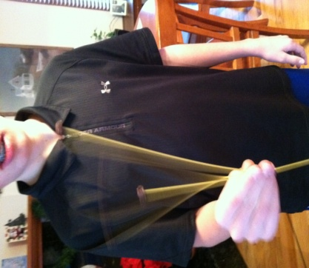Place a raisin or marshmallow on the end of a stick of spaghetti. Shake your hand back and forth to make the pasta/raisin system oscillate.

1. ***Does the period depend on the mass?***
2. ***Does the period depend on the length?***

Additional Questions:

1. Do you think this system’s motion would fall under the classification of *simple harmonic motion?* Provide as much evidence as you can for your answer.
2. Do your answers to A and B above match a spring/mass system or a pendulum? How so?
3. Do you think this system can be modeled as a pendulum, spring, or neither? What are your reasons for each?