Investigating How Music is Made

Name: __________________

Learning Goals: Students will be able to:
- describe how sounds are produced with vibrations.
- describe how tones can be varied by changing the length of the resonant cavity.
- describe how string instruments require a source of vibration, a way to change pitch and use sympathetic vibration to amplify sound.
- define frequency and vibration in terms of a sound wave and what we hear.
- generalize the ideas of vocalizing and making music. Both require a source of sound (vibrations), a way to change pitch (resonance) and a way to amplify sound (resonance or sympathetic vibration).

Predictions section – graded for completeness not correctness:
- What instruments, if any, have you ever played?

- Please describe with as much detail as you can, how an instrument makes sound. Pick at least two examples to describe.

- Please describe with as much detail as you can, how different tones are made with these instruments.

- Pull out your straw instrument from the previous class or make a new one.

You will need:
- Straws
- Scissors

Here’s what you do:
- Take the straw and the scissors, and cut off the tip of the straw to a point, like so. (Try to get both sides to be the same.)

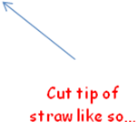

- Now, gently chew on the straw to soften the tip, and to get the edges to be smooshed together. You would like the two tips to be almost touching each other.
- Now, put the pointy end in your mouth, and blow really hard. If you do it right (it might take some practice), you will get a very loud sound from the straw instrument!

- How do you make the lowest possible pitch with your “straw trombone” (that’s when you slide a second straw over the initial straw)

- How do you make the highest possible pitch with your “straw trombone”?

Make a new straw instrument with one long straw.
- Test out how your straw instrument sounds after you cut about an inch off.

- Keep cutting sections off, and compare how the sound changes.

- Think about natural frequency of something or the frequency it likes to vibrate at. What do you think determines the natural frequency of your straw instrument? Hint: What determines its pitch?

- Now use the water bottle. Blow over the top of the water bottle until you have a tone. Would you describe it as a low pitch or a high pitch?

- What kind of instrument does the bottle remind you of?

- Figure out how to make a new tone with the same water bottle. Describe what you did to vary the tone.

- What determines the natural frequency of the water bottle instrument?

- Would the straw instrument and the bottle instrument be woodwinds, strings or brass? Look at www.dsokids.com for information. Look under Listen By Instrument.

How did you decide this?

Your Voice
Hold your fingers against the front of your throat and say Aaaaah. Notice the
vibration against your fingers.
- Change the sound to an Oooooh. What do you notice with your fingers as you listen? How about your mouth?

- Change the sound to Eeeeee. What do you notice with your fingers as you listen? How about your mouth?

- Would you say the different vowels are made differently by your throat or your mouth?

- Now try Sssss, not Esssss. Does your throat vibrate? What is vibrating?

- How about Ffffff? What is vibrating?

Hold your hand to your throat while speaking. Pitch varies with the emphasis
given to different words. The last words of a question, for example is at a higher
pitch.

- Now, tie a 3 foot piece of string to a table leg. Pull it tight and pluck it. Does it make a sound? Would you say it is a musical sound? What does it sound like to you?

- What if you slide the string between your thumb and index finger? Does it make a sound? Is it quiet or loud? How would you describe the sound?

Cup Instrument:
You will need:
- Plastic cup
- String
- Paper clip

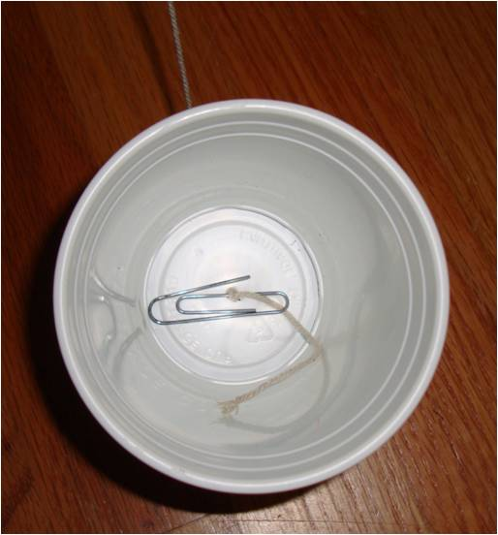
Take the cup and poke a hole in the bottom. Put the loose end of your string through the hole from the bottom, tie the end of the string that is inside the cup to the paper clip and then pull all the extra string out of the cup so the paper clip is on the bottom of the cup.

- Hold the cup so the string is loose and slide the string between your thumb and index finger. How does the sound compare to what you heard with just the string and no cup?

- Does this change in volume remind you of the sympathetic vibration of the table top when you placed a vibrating tuning fork on it?

- Now attach the string of your cup instrument to a table leg. Pull the cup so that the string pulls very tightly against the table leg. Pluck the string. Can you get a musical (ish) sound from it?

- Have your partner hold the string at different places from the table while you pluck the string near the cup. This way there are different lengths of string that can vibrate. How does the sound change?

- How can you make it louder?

- What instrument does this remind you of?

- Can you summarize three important features of your cup instrument that makes it 1. Make a sound, 2. makes it loud and 3. changes the pitch?

- How about your straw instrument from the previous activity? What were the three important features that make it 1. Make a sound, 2. make it loud and 3. changes the pitch?

- Get a wet paper towel and pinch the string very tightly as you slide the towel down it. If you do it right, you’ll get a very loud sound. What instrument does this remind you of?

- What is creating the vibration in this case?

- Did you hear any animal sounds? What sounded like what? Try to make a chicken (quick short slides), or a whale sound (long smooth slide) with the cup instrument.

Electric vs. Acoustic Guitars
- Compare the two types of guitars. Pluck a string on each one and compare the sounds. (Don’t be afraid to pluck firmly!)

- Why is the acoustic guitar so much louder? What is the difference between the two that causes the acoustic guitar to be loud?

- What happens if you press your finger on one of the frets along the neck of the guitar while you pluck that string? What happens if you hold the string down closer to the body (basically shortening the length of the string that can vibrate)?

- Name three stringed instruments that are “plucked” and three that use slip stick vibrations.

Compare cup instruments
- Find at least two other groups that have different cups than you used but the same string. How do their cup sounds compare to yours. What seems to be the cause of the differences, if any?

- Find one other group that has the same cup but used different string than you did. How does their cup instrument sound compare to yours? What seems to be the cause of the differences, if any?

