Thickness of a human hair
You can determine the width of a hair (d) using the equation for double slit diffraction (your hair acts as the center barrier):
d = $\frac{λ l}{y}$

where λ is the wavelength of light produced by your laser, l is the distance from the hair to the wall and y is the distance from the center to the first bright spot (y = PR).
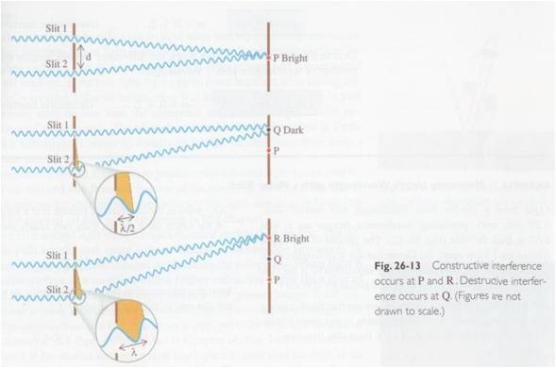

Prediction
Predict who in your group you expect to have the finest hair and who will have the thickest hair. What makes you think this?
Experiment
Materials - Laser, PASCO optics bench, component holder, slit mask, ruler, hair
Determine the thickness of a hair from each group member. Remove a hair from your head and tape it tightly across the slit plate so that the hair is perpendicular to the slit.
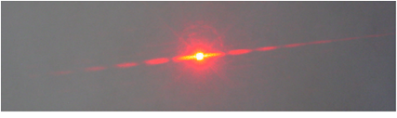
Now place the slit mask on a component holder in front of the laser beam. You will know you have the hair lined up perfectly when it is bright red from the laser beam reflecting off of it. The beam should be directed on a wall 2-3 meters away. Turn the lights off and observe the diffraction pattern.
Report
Post the thickest and the thinnest widths on the board.
Analyze
- Hair widths range from 17 - 180 μm. Are your values reasonable?
- From the diagrams on the first page, explain why a dark spot is formed when the difference in path length is λ/2 and why a bright spot is formed when the difference is λ.
- How do the diagrams on the first page of this lab match up with the diagrams on the “two source interference” tutorial that you completed for recitation today? Please draw and explain as much as necessary to make it clear how you visualize these two diagrams relating.

