Phys 220 – Inertia – Connected Objects
Part I
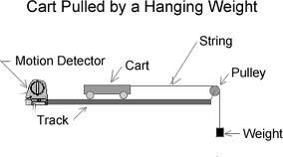
Materials and equipment: motion track, cart, string, pulley, hanging mass, motion detector
Prediction:
Consider the system to the right. What do you expect the acceleration of the hanging mass to be? The cart is nearly frictionless.
Experiment:
Use the motion detector to graph the velocity of the cart as the mass falls. Determine the acceleration of the cart using this graph. Print the graph and show how you determined the acceleration of the cart.
Is it what you expected?
Theory:
Can you think of a way, using Newton’s Laws, to explain the result?
Use Newton’s Laws to solve for the theoretical value of the acceleration. Hint: Use two free body diagrams, one applied to the hanging mass and one applied to the cart.
Find the experimental error between your theoretical and your experimental values of acceleration.
What are sources of error in this lab? Be very specific.

Part II – Phone Book Friction
Materials and Equipment: Two thick phone books
Interleave the pages of the two phone books. Have two group members each pull on one of the phone books.
How hard is it to pull them apart?
Use the ideas of frictional force to explain what is happening.

