Phys 220 - Inertia
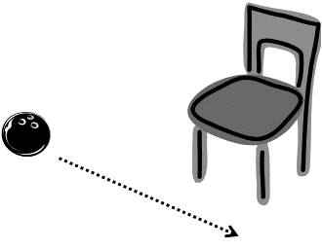
Part I – Croquet Bowling
Materials and Equipment: Bowling ball, croquet mallet and chair
Intergroup competition. The chair legs are the goal. Each person gets one roll and then passes the mallet for a total of 5 rounds – who can make the most goals? NO practice runs!
The bowling ball will be rolled by a group member who’s not currently the shooter. The roll must be slow and perpendicular to the goal as shown.
The shooter uses the croquet mallet to accelerate the bowling ball in the correct direction to score a goal. No pushing but multiple taps are allowed.
WARNING: It is possible to shatter the croquet mallet if you hit the ball too hard – be careful!
Write up: Describe, using force vectors, your final technique for scoring. Then describe your first try and why it did or did not work.
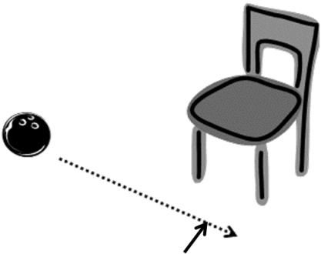
Diagrams:
- Draw a motion diagram of a bowling ball’s path if it is traveling in a straight line as shown and then a person taps it once firmly with a mallet at an angle of 90 degrees to the balls motion as shown by the arrow.

- Draw a motion diagram of a bowling ball’s path if it is traveling in a straight line as shown and then a person taps it multiple times a fraction of a second apart firmly with a mallet in the direction shown by the arrow.

- Draw a motion diagram of a bowling ball’s path if it is traveling in a straight line as shown and then a person pushes the ball continuously with a mallet in the direction shown by the arrow.

Question: Joe is talking to his roommate who’s in physics and he asks: “Why is it that a heavier object falls with the same acceleration, -9.8 m/s², as a lighter object if the heavier object has more inertia? If an object has more inertia, it’s harder to get it to move, the same force will give it less acceleration. Isn’t that what we just learned?” What is Joe missing?

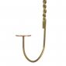
Part II - Centripetal Force Penny
Materials and Equipment: Wire hanger and a penny

Verify: Watch this Sick Science video. Determine if it’s possible to balance a penny on the hook of a hanger as you swing it in a circle.
Draw a free body diagram of the forces on the penny at a few different key points in the circle and explain why the penny remains at each point or flies off.

Part III – Egg Drop
Materials and Equipment: egg, glass, water, empty toilet paper roll, pie tin or light tray.
Fill the glass ¾ full of water.
Set the tray on the glass of water, stand the card board tube on the tray and balance an egg on the top of the tube.
With your writing hand, smack the edge of the pie pan horizontally. Don't swing up, and don't swing down! It’s important that you hit the pie pan horizontally and use a pretty solid hit, so plan on chasing the plate and tube.
Draw free-body diagrams of egg before and after the hit. Explain why it moves in the direction that you observed during your experiment.
Analyze:
Newton’s 1st Law: Objects at rest remain at rest. Objects in motion remain in motion unless acted upon by an outside force.
Identify which part (s) of Newton’s 1st law apply to each of the above experiments and explain your reasoning.

