Phys 220 - Inertia
Part I
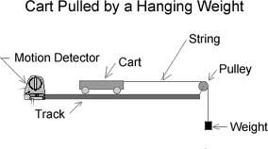
Materials and equipment: motion track, cart, string, pulley, hanging mass, motion detector
Prediction:
Consider the system to the right. What do you expect the acceleration of the hanging mass to be? The cart is nearly frictionless.
Experiment:
Use the motion detector to graph the velocity of the cart as the mass falls. Determine the acceleration of the cart using this graph. Print the graph and show how you determined the acceleration of the cart.
Is it what you expected?
Theory:
Can you think of a way, using Newton’s Laws, to explain the result?
Use Newton’s Laws to solve for the theoretical value of the acceleration. Hint: Use two free body diagrams, one applied to the hanging mass and one applied to the cart.
Find the experimental error between your theoretical and your experimental values of acceleration.
What are sources of error in this lab? Be very specific.

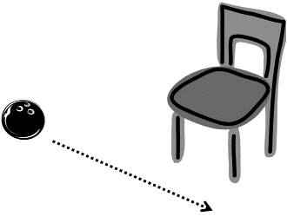
Part II
Materials and Equipment: Bowling ball, croquet mallet and chair
Intergroup competition. The chair legs are the goal. Each person gets one roll and then passes the mallet for a total of 5 rounds – who can make the most goals? NO practice runs!
The bowling ball will be rolled by a group member who’s not currently the shooter. The roll must be slow and perpendicular to the goal as shown.
The shooter uses the croquet mallet to accelerate the bowling ball in the correct direction to score a goal. No pushing but multiple taps are allowed.
WARNING: It is possible to shatter the croquet mallet if you hit the ball too hard – be careful!
Describe, using force vectors, your final technique for scoring. Then describe your first try and why it did or did not work.
Question: Why is it that a heavier object falls with the same acceleration, -9.8 m/s², as a lighter object if the heavier object has more inertia?

