Phys 220 - Density and Buoyancy

I. Density

Play around with the PhET simulation Density.

Determine the density of the five mystery masses A – E. Write a clear description of your experimental method including all your calculations. Identify the type of material that has a matching density to each mystery block.

- Does a can of soda float? Does it matter if it’s diet or regular? How about a bowling ball? Try it out and describe your results. Why do you think this is?

II. The Buoyant Egg

Materials: An egg, electronic balance, graduated cylinder, stirring rod, salt and tap water.
Useful Equation:

w = ρgV | w: weight of fluid (Newtons)  ρ: density of fluid (kg/mL)  g: gravity (9.8 m/s²)  V: volume of fluid (mL)
Experiment
- Determine the weight of your egg. Record this value in Table 1.
- Determine the volume of your egg. Record this value in Table 1.
Data
Weight of egg (Newtons)
Volume of egg (mL)
Density of salt water (kg/mL)
Table 1 Experimental data.

- Add salt to a warm bath of water until the egg floats (be sure to stir). IMPORTANT: make sure that the egg is FULLY submerged beneath the surface of the water (i.e. no portion of the egg is above water).

Analysis
- Determine the density of your salt water (find the weight of a known volume of your salt water). Record this value in Table 1.
- Compare the density that you determined in Table 1 to the density of the egg using percent difference. Are they the same (within experimental error) or different? Why is this so?
An object is buoyed up by a force equal to the weight of the fluid it displaces.

Questions
- What would you need to do in order to float some portion of the egg above the surface of the salt water?
- How would the volume of the displaced water compare to the volume of the entire egg?
- How would the weight of the displaced water compare to the weight of the egg?
- How would the density of this water compare to the density of the egg?
- Apply your plan from above to get half the egg to float.

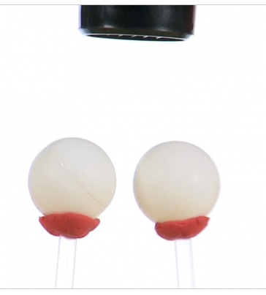
III. Ping Pong Pressure
Materials: Modeling clay or tape, Hairdryer, Straws, Ping pong balls

We have all experienced wind and, like it or hate it, it affects us. Moving air can jostle your hair about, fly a kit, or, in extreme cases, tear entire buildings from their foundation. Did you know that this moving air actually creates low pressure, though? It's true. On an exceptionally windy day, you can even see tall buildings bowing towards each other near their tops! We're going to recreate this phenomenon using ping pong balls in the Ping Pong Pressure experiment.

- Using what you’ve seen in the Ping Pong Pressure experiment, explain why your shower curtain “sucks in” when you take a shower. Describe what direction the net force is and what causes this net force.

