Doppler Effect
- Look at the “Sound” simulation on the PhET.colorado.edu site. Investigate how the wave changes as you adjust the various parameters. Draw a picture of a sound wave below. Draw a wave that is a low sound and one that is a high sound. What is different between the two?

- If a tuning fork is sounding and then swung over a person’s head, how do you think it will sound?

Demonstrationhttp://www.youtube.com/watch?v=sY7KhvdtB9I http://www.youtube.com/watch?v=a3RfULw7aAY
Listen specifically for the changes in frequency. Don’t worry about the change in loudness. The pitch should be high as it approaches and low as it drives away. The only change in pitch should be as it is passing.
- After listening to the demonstrations, describe what you heard.

- Prediction: Draw a picture or pictures that show how wave fronts (like shown in the Sound sim) might look while a speaker is moving towards you. Draw how it would look if the speaker were moving away from you.

Class Discussion and Explanation
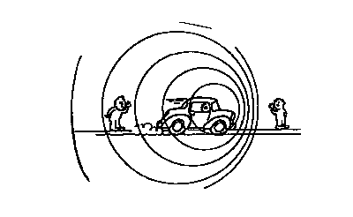
- Describe in your own words as you might to other students, how the Doppler effect works.
Most books use the terminology wave fronts when explaining the Doppler effect, however, in reality sound is continuously emitted from a source, not in spurts as one might think if you look at a drawing like the one to the right. Think of a wavefront as the crest of the wave.
In the case where the source is approaching an observer, each wavecrest is emitted closer to the observer than the last so the space between waves, wavelength, is shortened due to the motion of the source. This means the received wavelength to be shorter which we perceive as a higher pitched sound. Vice versa if the source is moving away.

