Fable: A Lost Child Keeping Warm
(adapted from Original ChemStudy text)

Once upon a time a small child became lost. Because the weather was cold, he decided to gather materials for a fire. As he brought objects back to his campfire, he discovered that some of them burned and some of them didn't burn. To avoid collecting useless substances, the child began to keep track of those objects that burned and those that did not. (He organized his information.) After a few trips, his classification contained the following information.

FLAMMABILITY
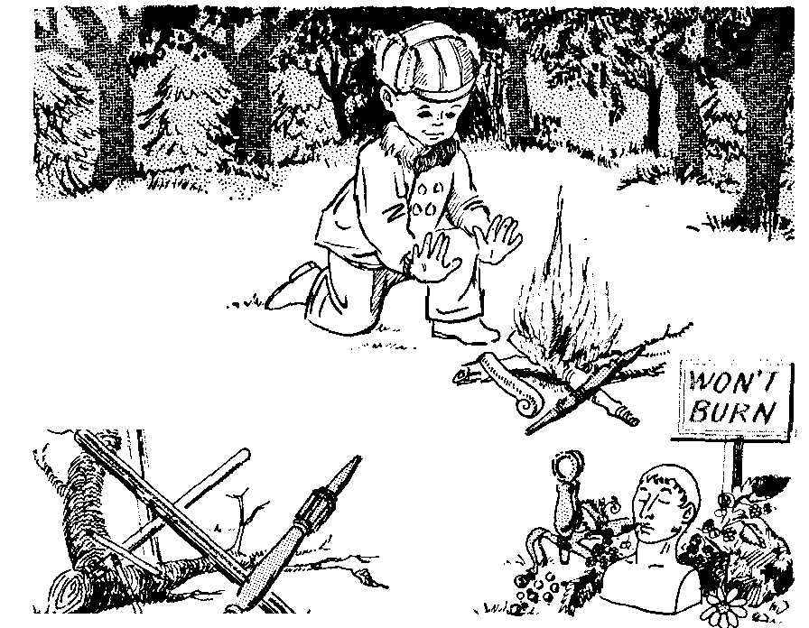
WILL BURN
Tree limbs
Broom handles
Pencils
Chair legs
Flagpoles

WON'T BURN
Rocks
Blackberries
Marbles
Paperweights

This organization of the information was quite an aid in his quest for warmth. However, as tree limbs and broom handles became scarce, the child tried to find a regularity that would guide him to new burnable materials. Looking at the pile of objects that failed to burn and comparing it with the pile of objects that would burn, the child noticed that a regularity appeared. He proposed a possible "generalization."

Perhaps: "Cylindrical objects burn."

This procedure is one of the elementary logical thought processes by which information is systematized. It is called inductive reasoning, and it means that a general rule Is framed on the basis of a collection of individual observations (or "facts"). Of what use is the inductive process? It is an efficient way of remembering.

The next day the child went looking for burnable materials, but he forgot to bring along his list. However, he remembered his generalization. So, he returned to his hearthside hauling a tree limb, an old cane, and three baseball bats (successful predictions!). What's more, he reflected with pleasure that he hadn't bothered to carry back some other objects: an automobile radiator, a piece of chain, and a large door. -Since these objects weren't cylindrical there was no reason to expect them to burn.

No doubt you are ready to complain that this generalization isn't really true! Quite the opposite! The generalization states a common characteristic discovered among all the observations available, and as long as observations are restricted to objects in the list, the generalization is applicable. A generalization is reliable within the bounds defined by the experiments that led to the rule. As long as we restrict ourselves to the objects on his list (together with canes and baseball bats) it is surely true that all of the cylindrical objects burn!

Because of his successful predictions, the child became confident of his generalization. The next day he deliberately left the list at his campsite. This time, with the aid of his rule, he came back heavily laden with three pieces of pipe, two ginger ale bottles, and the axle from an old car, while leaving a huge cardboard box full of newspapers.

During the long cold night that followed he drew these conclusions:

(1) The cylindrical shape of a burnable object may not be associated with its flammability after all,
(2)Even though the "cylindrical" rule is no longer useful, tree limbs, broom handles, pencils, and the other burnables in his list still burn.
(3) He'd better bring the list along tomorrow.

But, thinking over the longer list, he saw a new regularity that fit:

Perhaps: "Wooden objects burn,"

What good is this rule in the light of the earlier disappointment? Well, it caused the child to go back and get that door he had passed up two days earlier, but it didn't lead him to go after the chain, the automobile radiator, or the cardboard box full of newspapers.

Don't think this is facetious-it is exactly what science is all about! We make some observations, organize them, and seek regularities to aid us in the effective use of our knowledge. The regularities are stated as generalizations that are called theories. A theory is retained as long as it is consistent with the known facts of nature or as long as it is an aid in organizing our knowledge. We can be sure that some day a number of our present scientific views will seem as absurd as "Cylindrical objects burn." But on that day we will be proud of better views that have been substituted. If you are discouraged by the child's faltering progress-he hasn't yet decided that the box of newspapers will burn-be reassured. This child is a scientist and his faltering steps will lead him to the newspapers. They are the same steps that led us to our present understanding of relativity, to our discovery of polio vaccine, and to our propulsion of rockets to the moon.

LESSON PLAN (Adams):
Learning Goals:
- Students will understand how a generalization can be made based on only observation.
- Students will understand that a generalization that fits our current observations may be found to be incomplete or incorrect once new data is gathered.
- Students will understand that a generalization can be proven wrong with only one more bit of data but it’s not possible to prove a generalization correct.

I find that this story works best if the class is interrupted at key points and asked to participate.

I write the lists of will burn and won’t burn on the board.
Then ask them to discuss the following 4 generalizations with their neighbor and decide if they fit the lists on the board. Consider only what’s on the board.
- Things that float will burn
- Cylindrical (long and round) objects will burn.
- Man-made objects will burn
- Things made of wood will burn.
Now ask for volunteers to discuss each of the above and how it fits the burn lists. They come up with some good nitpicky reasons some fit and some don’t during this discussion.

Read again until the boy suggests that “wooden objects burn” .

Ask the class how this helps him. Does it completely classify what’s available? Ideas? Again this is discussed with neighbor so they’ll all talk rather than a few.

Finish story

Ask the class to settle on a rule for what burns.

Now ask “can we prove this?” Discuss in groups and then report out. Students not comfortable jumping into the discussion before talking to their groups. Asked someone from each option to state their reasoning. Discussion went really well and the class decided you can’t prove it without trying every kind of dry wood (dry wood was a possible generalization since cardboard is derived from wood) Discussed how a very specific statement of “this piece of wood will burn” can be proven but a generalization similar to what in general will burn could not be proven.

