Conservation of Energy

- Graphing
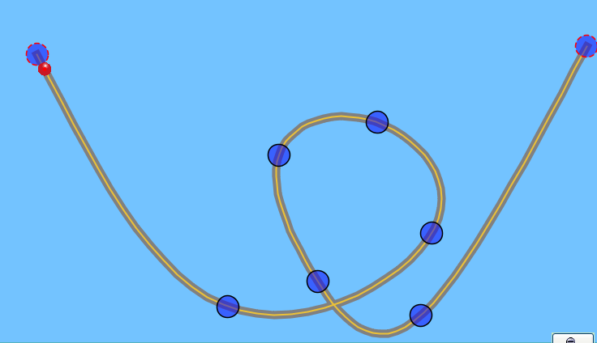
- Kaiya made a frictionless track that looks like the one shown. She placed a red rubber ball on the top left of the track at 1.
2
1
3
4
  - Make a data table like the one below on your lab write up.
  - Fill in the Prediction column by sketching what you think the Pie chart will look like for the ball at points 1-4.
  - Use the Loop Track with the Ball Skater to test your ideas and make any adjustments

 | Pie chart
 | Prediction | Simulation | Explain differences
1
2
3
4

- If the bulldog were to ride this track,
  - What do you think would change about the pie charts?

  - Explain why you think the charts would be similar or different.

  - Check your reasoning using the simulation and make corrections if necessary.

- What if this was a real track with friction.
  - What do you think would change about the energy pie chart? Show these pie charts in the table below.
 | Pie chart
 | Prediction | Simulation | Explain differences
1
2
3
4

- Explain why you think the charts would be similar or different.

- Check your reasoning using the simulation and make corrections if necessary.

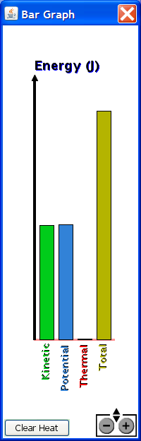
- Explain how you can predict a bar graph (shown on the right) from a pie chart.



- Draw the bar graph that matches this pie chart.

- Sketch this track on a separate sheet of paper (or on the back of this sheet) and label where the 5 spots could be.

- He is at his maximum speed
- He is stopped
- He is going his average speed
- He is going slow
- He is going fast

- Sketch this energy-position graph and label where you think the same 5 spots are.
- He is at his maximum speed
- He is stopped
- He is going his average speed
- He is going slow
- He is going fast

