How Hot Are Your Hot Wheels™? Name____________________
Problem: Period ______
How can you apply the Law of Conservation of Energy to predict the minimum height needed to
release a car on a loop-the-loop track so that the car just barely retains contact with the track through the loop?
Materials:
Hot Wheels™ track with loop-the-loop
small car
meter stick
masking or duct tape
calculator
Procedure A: Loss of Energy Due to Friction
The illustration below shows the track setup for Procedure A. Elevate both ends of the track to form a U-shape with the track.
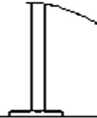
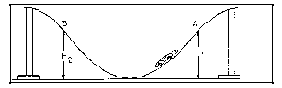
Release the car from the starting point A. Record this height (h1) and the height to which the car rises (h2) on the other end of the track. Complete several trials. It is important to secure the track to the floor so some of the car's energy is not transformed into motion of the track.
The ratio of the final height to the initial height is equal to the ratio of potential energy transferred back into the car going up the left ramp to the potential energy the car had at the top of the right ramp at point A. Call this ratio of h2 to h1 the "efficiency" of the system for the car going from point A to point B on the track. The distance along the track from A to B is called the "standard length" so the ratio of h2 to h1 (efficiency) represents the fraction of the initial energy the car will have when it reaches point B on the track. This ratio is used in later experiments to determine how high the car must start, so it will have a predictable total amount of energy when it reaches certain points on the track.
h1
h2
B
A
Summing Up:
- What is the average height ratio, or efficiency? (Show your work)

2. In what unit is efficiency measured?

Procedure B: Loop the Loop
The next illustration shows a loop-the-loop section placed in the track at about the standard length from the starting end of the track. The problem is to predict the minimum height from which the car must start, so it will successfully travel all the way around the loop.
Go ahead and setup your track like this now!
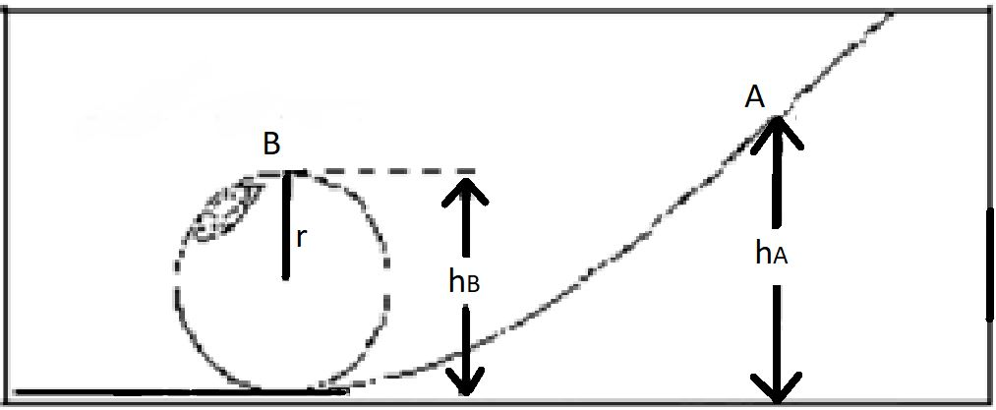
At point B in the diagram, if the car just barely makes it through the loop, we approximate that the only FORCE acting on it at that time is the force of gravity. The force of gravity gives objects their weight, and can be calculated:
Weight = mg
Since the weight is directed inward toward the center of the Loop the Loop it is also the centripetal force. The equation for centripetal force is below:
F_{c} = mv ² / r
Since Weight is the centripetal force, you can combine the two equations from above like this:
mv ² / r = mg
Now rearrange this equation to solve for v, which is the minimum speed needed at the top of the loop for the car to perform a successful loop. Keep in mind that “r” is radius – and is half the diameter of the loop. (Show your work)

At the top of the loop, the car has both kinetic and potential energy. This energy total was supplied by the potential energy the car had at a point A. This means:
KE(at B) + PE(at B) = PE(at A)
or
1/2mv² + mgh_{B} = mgh_{A}

Substitute the value of v you found earlier into the energy equation and then solve the equation for h_{A}. This means that if there were no friction, the car should start from a height, h_{A}, to make it around the loop. (Show your work.)

Now try dropping your car from height h_{A} to see if it successfully makes the loop.

Since the system does have friction, the car must start from a point just higher than h_{A} to make up for the frictional loss. Therefore the car must start from a height of h_{A} divided by the efficiency of the system. What is this calculated height, which accounts efficiency? (Show your work)

Try it out! Did it work? If not, explain the source(s) of error that may have kept your car from making the loop.

Summing Up:
- State in your own words the energy changes as you lift the car to point A, until it
completes the loop-the-loop. (You can draw and label a picture if you’d like.)

2. Do your results show that energy is conserved? Explain your answer.

